  Anne Ladd  Family Engagement Specialist  GaDOE | 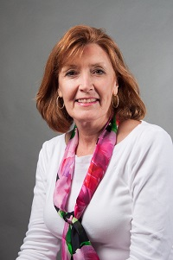  Debbie Currere  Parent Support Specialist  Ga SPDG

