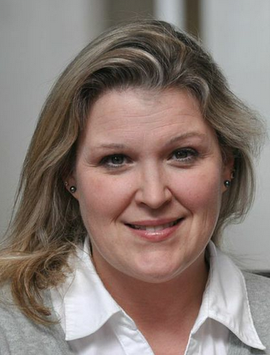  s  Ashley Gellis  Marietta City  Regio  Ashley Gellis  Marietta City  Region Rep | 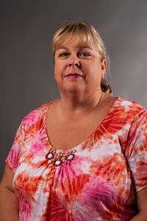  Sharon Hall  Cherokee | 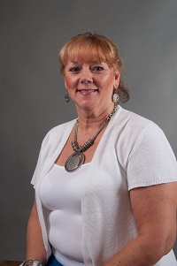  JoEllen Hancock  Cherokee  LC Sunshine Fund |   Ashley Wallace  Clayton | 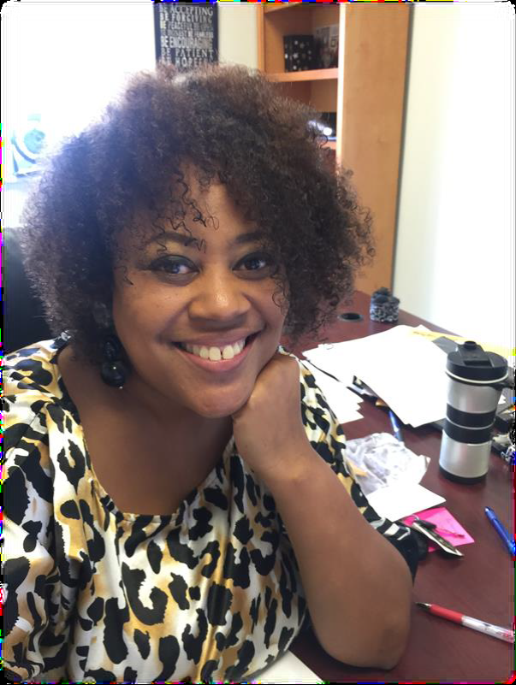Karen Tanks  Clayton | 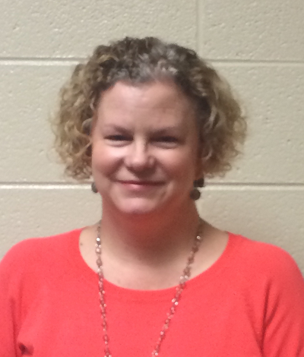 Stacy Greene Cobb | 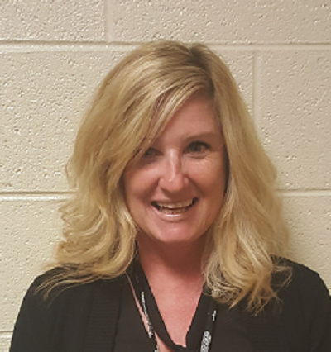  Melissa Tellekamp  Cobb | 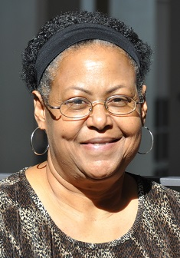  Linda Earley Williams  DeKalb
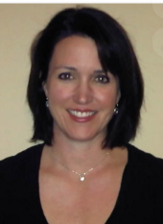  Alexandra Wright  DeKalb | 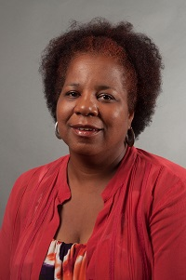  Sabrinia Gresham  Fulton | 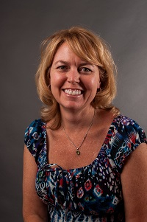  Patti Grayson  Fulton | 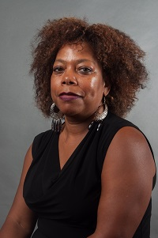  Jackie McNair  Gwinnett | 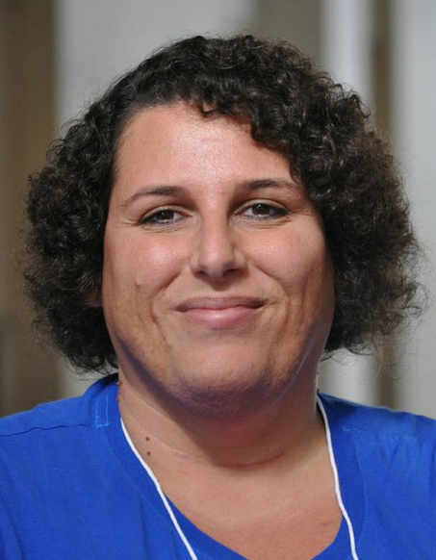  Dawn Albanese  Gwinnett | 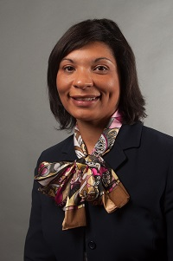  Vernita Harris  Muscogee | 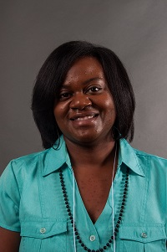  Lakisha Smith  Muscogee | 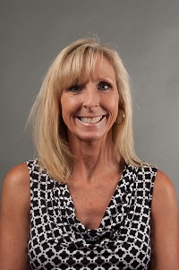  Caroline Hull  Rockdale
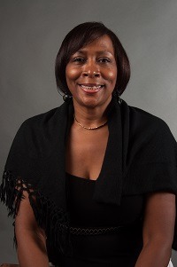  Edith Abakare  Atlanta City | 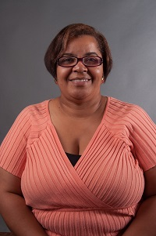  Rose Calloway  Atlanta City | 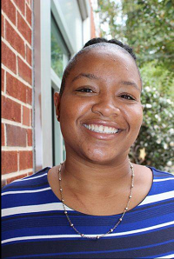  Cheryl Grant  Decatur City | 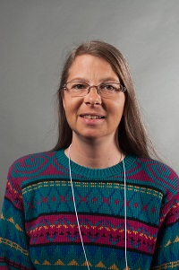  Jennifer Anderson  Ga Cyber  Academy | Open  Atlanta Area School for the Deaf | 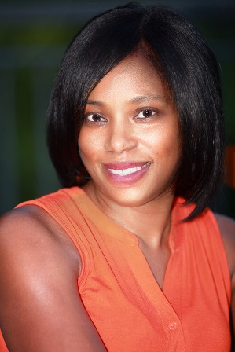  Doricia Thompson  DJJ | Always room for more | Always room for mere

