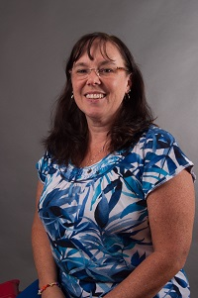  Nancy Grabe  Marietta City  Region Rep | 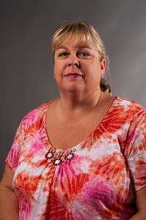  Sharon Hall  Cherokee | 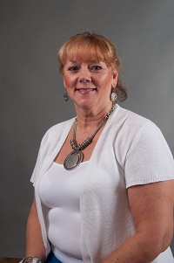  JoEllen Hancock  Cherokee  LC Sunshine Fund | 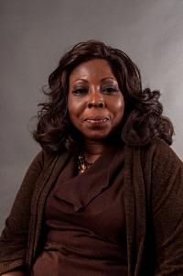  Opal Simmons  Clayton | 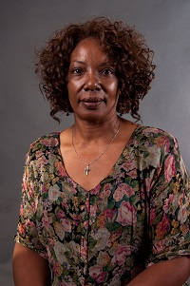Stephanie Simms  Clayton | 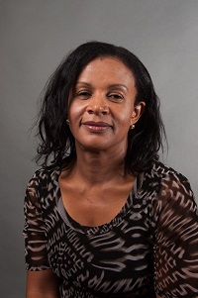Ijeoma Ajoku Cobb | 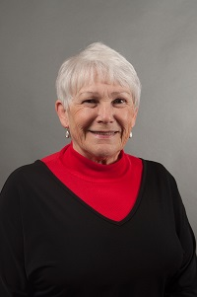  Judith Steuber  Cobb | 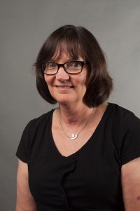  Madeline Griffin  DeKalb
 | 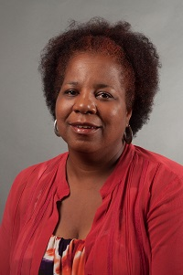  Sabrinia Gresham  Fulton | 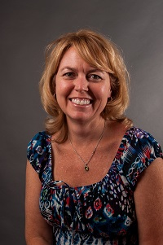  Patti Grayson  Fulton | 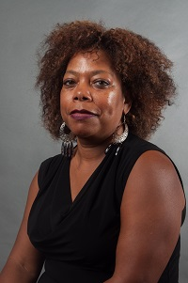  Jakcie McNair  Gwinnett | 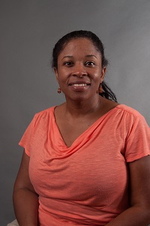  Sonya Powell  Gwinnett | 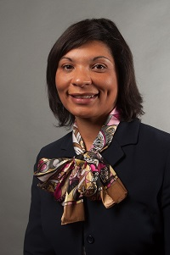  Vernita Harris  Muscogee | 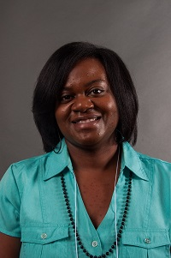  Lakisha Smith  Muscogee | 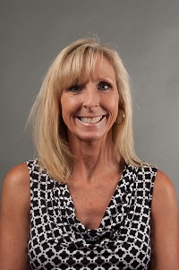  Caroline HJll  Rockdale
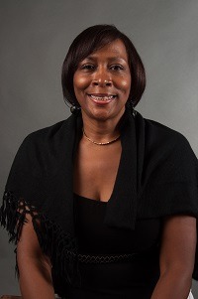  Edith Abakare  Atlanta City | 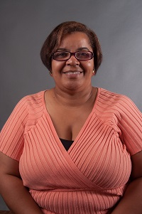  Rose Calloway  Atlanta City | 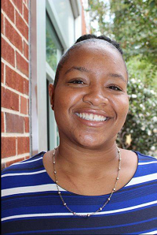  Cheryl Grant  Decatur City | 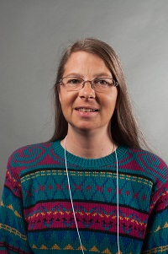  Jennifer Anderson  Ga Cyber  Academy | Vacant  Atlanta Are School for the Deaf | Always room for more | Always room for more | Always room for mere

