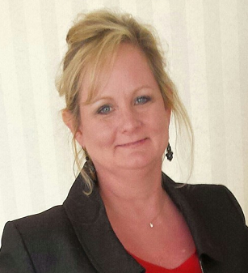  Kathy Simmons  Dodge  LC past chair  Region Rep | 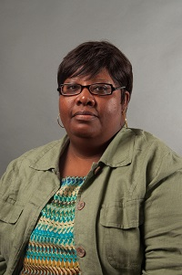  Donna James  Baldwin | 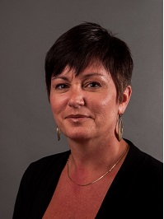  Terri Goodridge  Bibb | 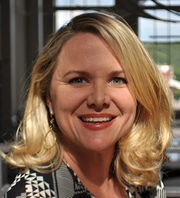  Jennifer Minter  Bibb | 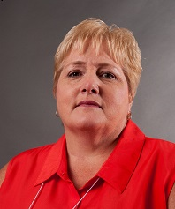  Cheryl Whitaker  Crawford | 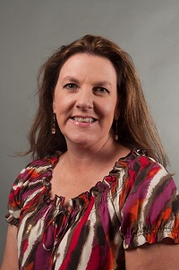  Allison Stevenson  Fayette  LC past chair | 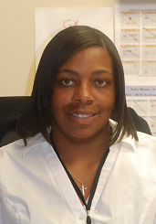  Jacqueline Evans  Greene |   Always room for more
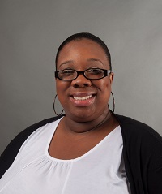  Taka Taylor  Hancock | Carolyn Heard  Henry | 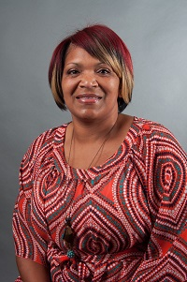  April Wooten  Jones  LC | Cindy Clendenis  Jasper |   Marina Jones  Houston |   Regina Lindsey  Johnson | 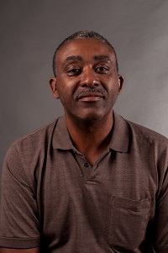  James Butler  Lamar | 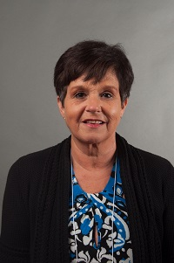  Ginger Henderson Meriwether
Open  Monroe | 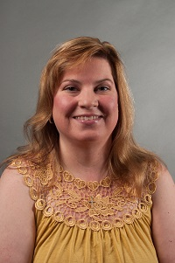  A.Diane Johnson  Newton | 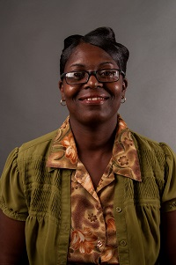  Cynthia Criss  Pulaski | 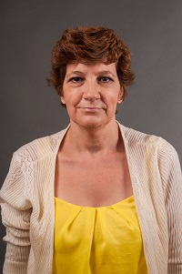  Dayna Moeller  Putnam | 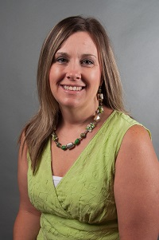  Taimie Hoffman  Thomaston Upson | Barbara Bryant  Twiggs | 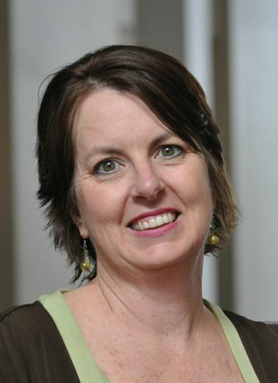  Sonya Milam  Ga. Academy for the Blind | Always room for more

