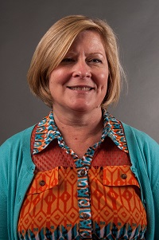  Amy McCollum  Oconee Region Rep | 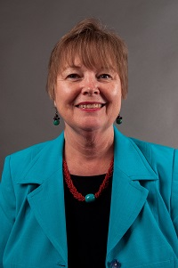  Marsha Sahlman  Hart Region Rep assistant, LC education chair | 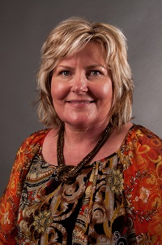  Mellie Caudell  Banks | 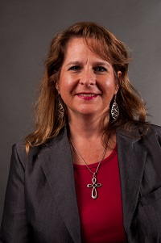  Cyndi White  Barrow  LC chair 2013-14 | 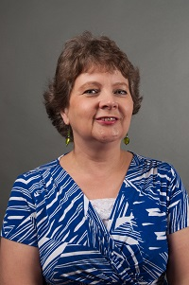  Jerolee Oschack  Clarke | 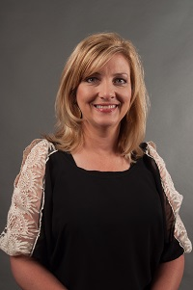  Heloise Salter  Columbia | 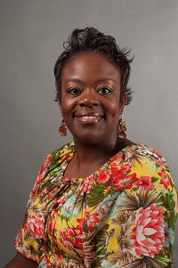  Wausheka McClary  Elbert | 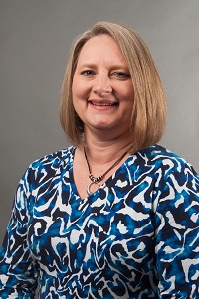  Teresa Bruce  Franklin
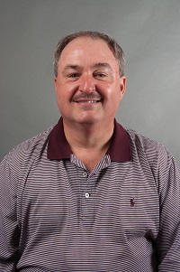  Scott Crain  Hall  LC past chair | 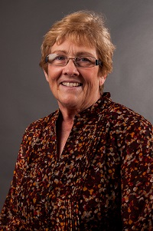  Barbara Bosanko  Lumpkin | 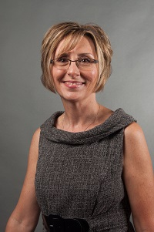  Pamela Walley  Madison  LC past chair | 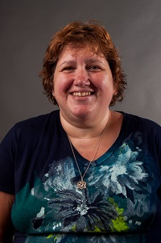  Jodie Zeuke  Oglethorpe | 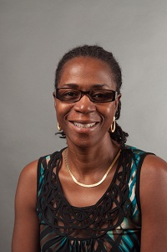  Cassandra Stone  Richmond | 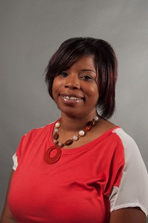  Saundra Kelly  Richmond | 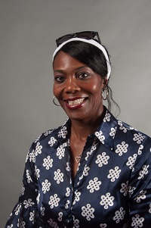  Annetta Mayfield  Stephens | 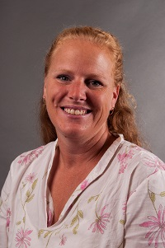  Becky Tracy  Union
  Vacant  Walton | 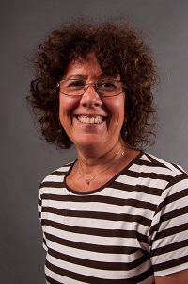  Jane Grillo  White County GaPMP  web editor | 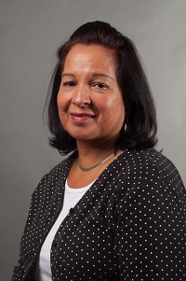  Maritza Rivera  Gainesville City | Always room for more | Always room for more | Always room for more | Always room for more | Always room for mere

