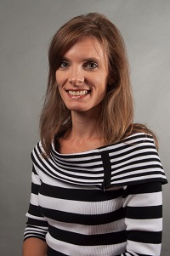  Kim Chester  Bartow  Region Rep | 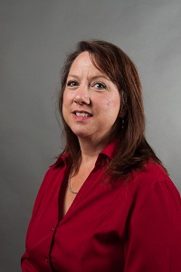  Michal Jones  Walker  Assistant Region Rep | 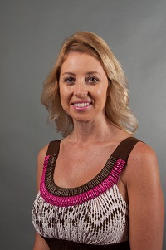  Robin Smith  Catoosa |   Jenn Williams  Coweta | 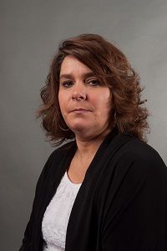Cynthia Daniels  Dade | 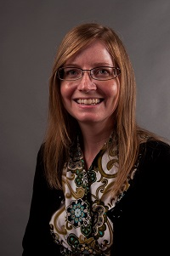  Renee Davis  Douglas | 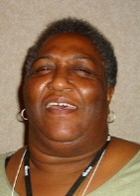  Jean Moorehead  Gordon | 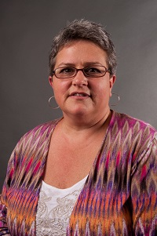  Cheryl Benefield  Haralson
Together We Can | Vacant  Paulding | 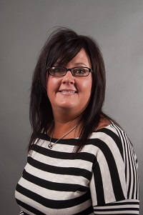  Tracy Reynolds  Polk | 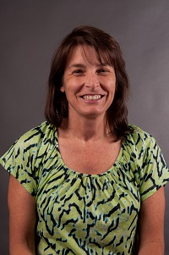  Jodie Mazzolini  Troup  LC Recorder | 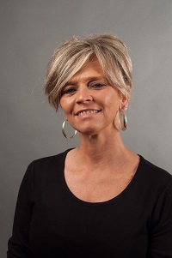  Erin Arledge  Whitfield | Nancy Horner  Dalton City | 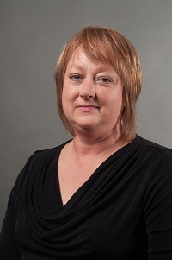  Linda Young  Trion City | Always room for more
Always room for more | Always room for more | Always room for more e | Always room for more | Always room for more | Always room for more | Always room for more | Always room for mere

