  Amanda Locke  Evans  Region Rep |   Tameka Tribble  Chatham  Assistant Region Rep | 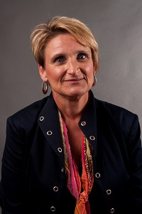  Pat Hailey  Appling | 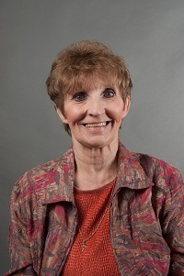  Becky Bryant  Bryan | 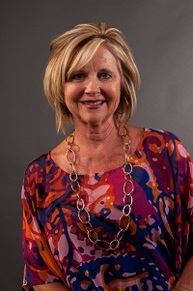 Carol Smith  Candler | 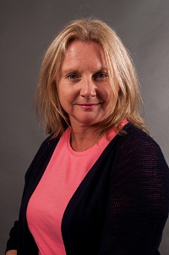  Julie Hardeman  Chatham | 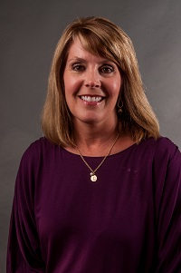  Lori Bonds  Emanuel |   Kathy Johnson  Effingham
  Shirley Moore  Glynn | 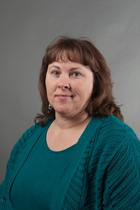  Lisa Vaughn  Liberty | 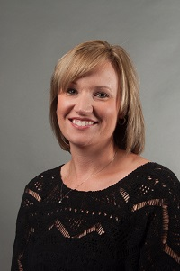  Kristi Murphy  Pierce | 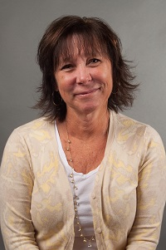  Kim Gibson  Ware | 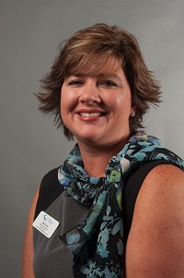  April Lee  Wayne  LC Past Chair | Always room for more | Always room for more | Always room for more
Always room for more | Always room for more | Always room for more | Always room for more | Always room for more | Always room for more | Always room for more | Always room for mere

