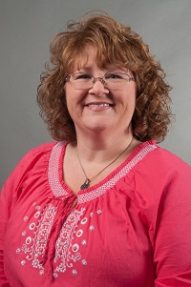  Cathy Green  Early  Region Rep | 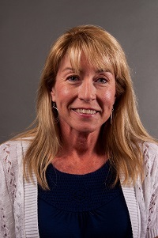  Janie Kelly  Decatur  Assistant Region Rep | 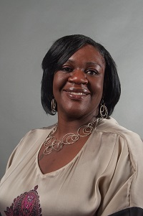  Tracy Barber  Baker  LC past chair | 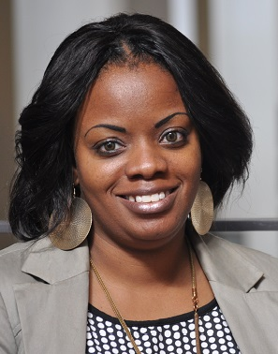  Kristi Hodge  Dougherty | 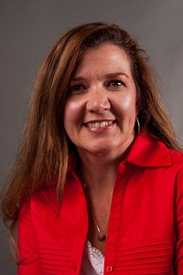  Rebecca Best  Grady | 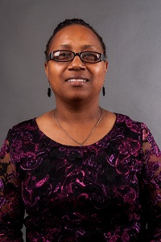  Shanitha Jones  Marion | 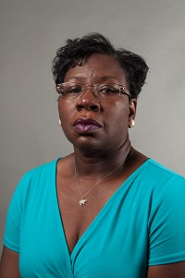  Shirley Daniels  Mitchell | 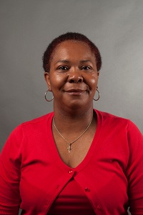  Latonia Mansfield  Terrell
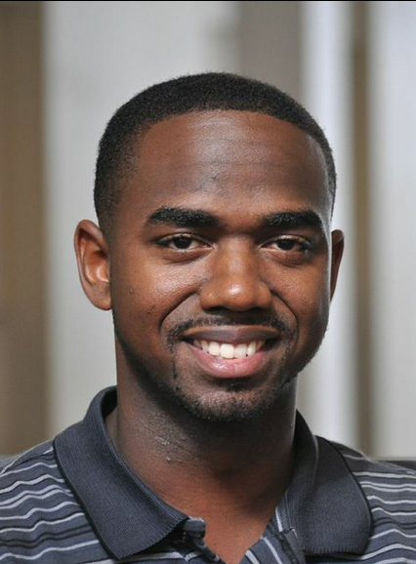  Darius Brown  Stewart | 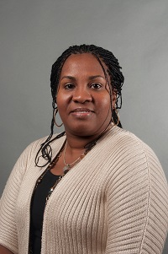  Yolanda Sanford Sumter | 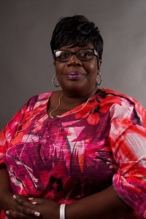  Eloise Wells  Thomas | 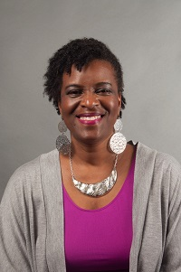  Deborah Bryant  Thomasville City | 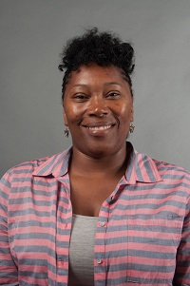  Felisha Draggs  Pelham City |   Always room for mere | Always room for mere | Always room for more
Always room for more | Always room for more | Always room for more e | Always room for more | Always room for more | Always room for more | Always room for more | Always room for mere

