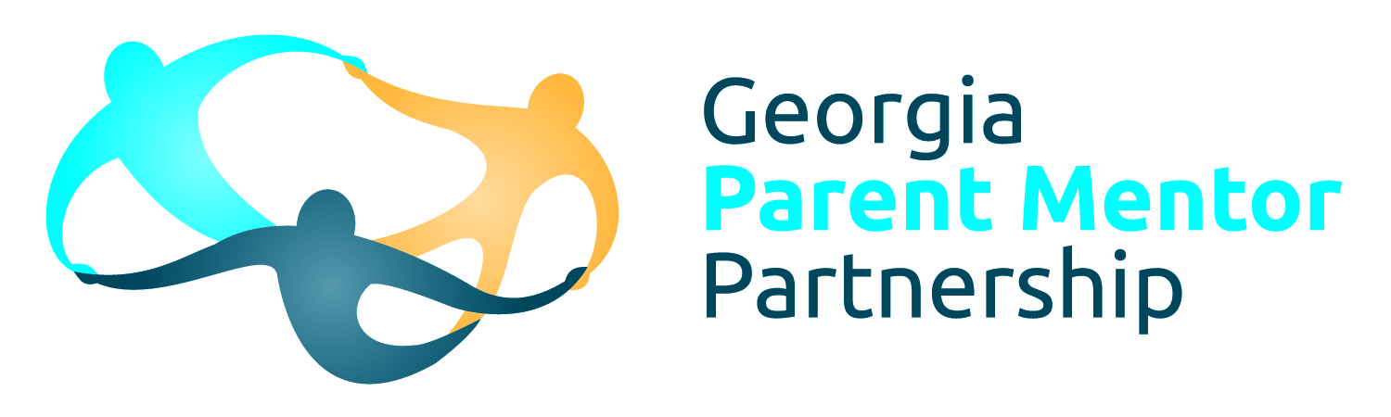

**Parent Mentor Partnership**

**2015-2016 Leadership Council**

**Executive Board**

**Chairperson** –Allison Stevenson, *Fayette*

**Chairperson Elect** – Amy McCollum, *Oconee*

**Vice Chairperson** – April Wooten, *Jones*

**Recorder** – Diane Johnson, *Newton*                

**Immediate Past Chair**- Cyndi White, *Barrow*

**Region Representatives**

**Northeast** - Teresa Bruce, *Franklin*

**Northwest** - Rene Davis, *Douglas*

**Metro** - Edith Abakare, *Atlanta Public Schools*

**Middle** - Terri Goodridge, *Bibb*

**Southeast** - Lori Bonds, *Emmanuel*

**Southwest** - Joseph Randall, *Decatur County*

**Committees**

**Special Projects** Kim Chester, *Bartow*

**Education**  April Lee, *Wayne*

JoEllen Hancock, *Cherokee*

**Phil Pickens Award Chair** Cyndi White, *Barrow*

**Sunshine Fund** JoEllen Hancock, *Cherokee*

**Advisors** Ann Cross, *Gordon*

Charity Roberts, *Coastal GLRS*

Gordina Porter, *Mitchell*

**Other supports**

**Family Engagement Specialist** Anne Ladd, *GaDOE*

**Communications Coach** Jane Grillo, *White*

**Data Coach** Cynthia Criss, *Pulaski*