

**RESOURCE FAIR for KIDS with SPECIAL NEEDS/DISABILITIES**

***REACH for the SKY!!***

**Porterfield Methodist Church Family Life Center**

**2200 Dawson Rd. Albany, GA**

**FREE EVENT! All families in attendance will be registered for a $50.00 Gift Card drawing**

**Saturday, January 24, 2015 10:00 a.m. – 2:00 p.m.**

**Please come browse, chat, or collect information from a variety of national, state, and local organizations: Fragile Kids Foundation, Easter Seals, CHOA, Epilepsy Foundation of GA, GA Telehealth/Telemedicine, BCW/CMS Programs, Behavior Specialists, National Organization of Rare Disorders, Marcus Autism Center, and many more.**

**Contact Jenn Nolder at** [**Jenn@fragilekids.org**](mailto:Jenn@fragilekids.org) **770-951-6396 for details. Sponsors for this Resource Fair are Fragile Kids Foundation, Easter Seals, Babies Can’t Wait Program, Children’s Medical Services Program, and Children’s Healthcare of Atlanta/Sibley Heart Center Cardiology,**

**Directions to Porterfield Methodist Church: Go to** [**www.mapquest.com**](http://www.mapquest.com) ***Note: A wheelchair ramp is in the back entrance of the church. Parking is available in the back of the church and on the side parking lot near Lullwater Rd*.**

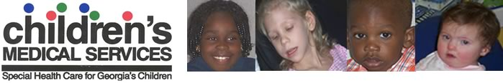

[](http://www.easterseals.com/northgeorgia) [](http://www.easterseals.com/northgeorgia/)  [](http://www.google.com/url?sa=i&rct=j&q=&esrc=s&source=images&cd=&cad=rja&uact=8&ved=0CAQQjRw&url=http://www.resurgensfoundation.com/success/projects/fragile-kids-foundation/22&ei=YdNgVJaQAcaqNvLcgrgN&bvm=bv.79189006,d.eXY&psig=AFQjCNHQwsAbnx5L20Ncei_VlcP_zCDb1Q&ust=1415718113053276)