SGA & IPSE

Student Government Association and Inclusive Post-Secondary Education

Campus Day

**[](http://www.google.com/url?sa=i&rct=j&q=&esrc=s&frm=1&source=images&cd=&cad=rja&uact=8&ved=0CAcQjRw&url=http://holykaw.alltop.com/secrets-of-successful-college-students&ei=HkPmVOqUJcemNoGtg6AM&bvm=bv.85970519,d.eXY&psig=AFQjCNEc-TRKwqJHTchqfMqyHDq5EgLqLA&ust=1424463003398649)[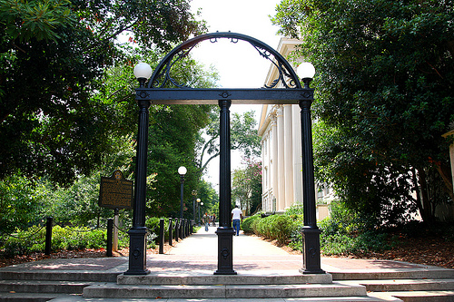](http://www.google.com/url?sa=i&rct=j&q=&esrc=s&frm=1&source=images&cd=&cad=rja&uact=8&ved=0CAcQjRw&url=http://georgiapoliticalreview.com/qa-with-dr-derek-eberhart-uga-director-of-tech-commercialization-office/&ei=VUPmVLqsNISqggTGuYPwDg&bvm=bv.85970519,d.eXY&psig=AFQjCNFfeVvJxT79D21DwbEalmhRZ1li3Q&ust=1424463056564073)*April 10,* *2015*

Space is Limited!

College Tour of UGA led by UGA students

Sit in on a college lecture

Eat in a college dining hall

To Register/Information

Email: lrl@fanning.uga.edu

*9:30a-3:00p*