
Tip Sheet for Data Collection
Regular Positive Communication Communication Logs
If your Vital Behavior is: “Teacher and family will discuss and plan for regular positive communication based on the child’s progress home/community activities, or as a way of seeking parent input by preferred method of communication.”
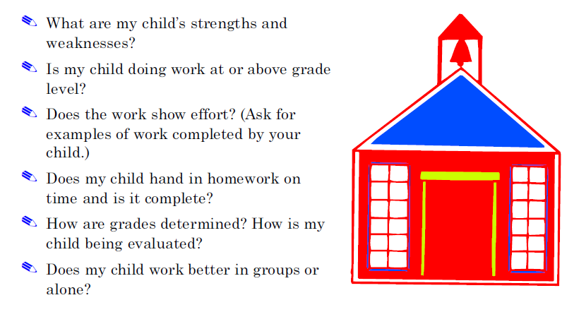
From the Pacer Center Communication Guide posted on the Learning Curve: These could be the questions that parents track to gauge success. Create a log sheet or quarterly survey form with these questions to use for data collection.

Other options: See samples of the Parent Communication Log or the Weekly Progress Report on the back. These forms can be downloaded from the Learning Curve.
