
Tip Sheet for Data Collection
Regular Positive Communication Transition Timelines
If your Vital Behavior is: “Family and students will access GACollege 411 or equivalent for an Individual timeline and track activities (job shadowing, college visits, Vocational Rehabilitation counseling and etc.) each grading period. “

GaCollege411 Link to this page to create a timeline. Use the tabs for the appropriate grade level: https://www.gacollege411.org/High_School_Planning/High_School_Planning_Timeline/Landing_Page.aspx

If you are working with a family who has a child not planning to attend a post secondary college program, there are other timeline tools that you could adapt. AbilityLinks https://www.abilitylinks.org/ is a resource for people with disabilities who are searching for employment
This link offers a transition timeline for elementary through post secondary. To create data have the family pick three to all of the items on the checklist and report progress monthly or quarterly using a communication log (download one from the learning curve)
https://www.abilitylinks.org/docs/tpc/TPC_2006_02_Transition_Timeline.htm

For those families tracking Vocational Rehabilitation progress: The National Association of School Psychologists offers a skills checklist for post secondary employment for SWD.
See checklist on back. Parents could choose items from this list and identify which they have worked on through a communication log:
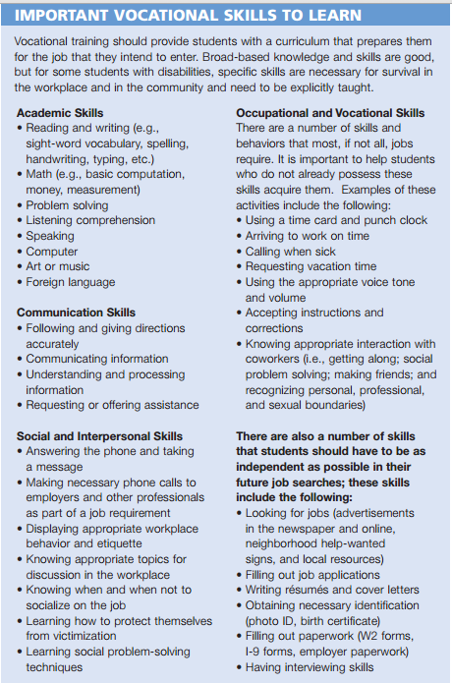

Need more help? Consult your regional rep.

