
Tip Sheet for Data Collection
Regular Positive Communication
Transition Assessment
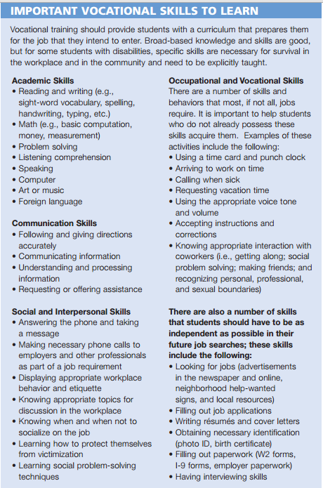
If your Vital Behavior is: “Results from a transition assessment will guide family and students to work together to complete a series of work-readiness exercises, reporting progress monthly.”
Hint:
This vocational skills list can help a parent and student identify goals and help inform discussion with the Vocational Rehabilitation Counselor and/or IEP team and then track progress using communication log.

Here are some links to Vocational Assessment Tools:
http://rbed.sharpschool.net/UserFiles/Servers/Server_5246344/File/Special%20Education/Secondary%20Transition/Functional%20Vocational%20Skills.pdf
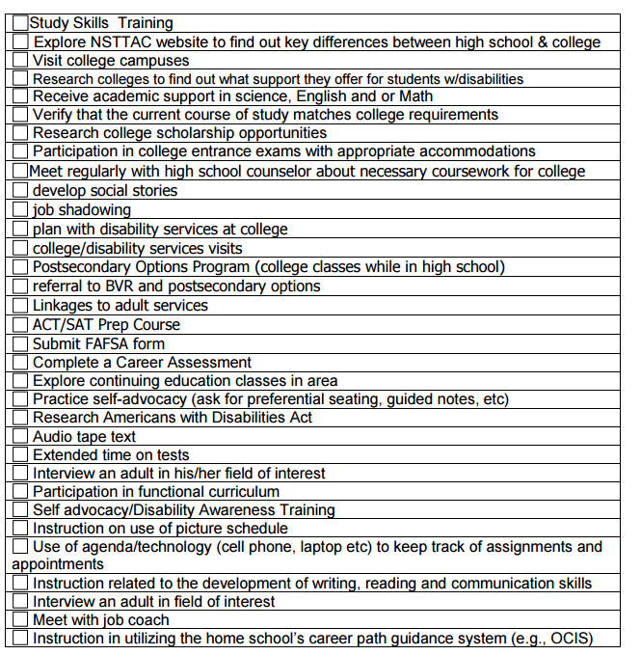
Here is a whole list of downloadable assessments: http://sped.sbcsc.k12.in.us/ppm/transitionplanning/transitionassessments.html#downloads
Hint: The chart above comes from Akron Ohio Schools website. This chart might be a great log for parents to weekly, or monthly identify two activities and goals to work on. Then, the mentor can collect the charts and see what progress has been made…

