
Tip Sheet for Data Collection
Regular Positive Communication Attendance, Behavior and Academic Performance
If your Vital Behavior is: “Family and student will track ongoing conversation by using a calendar and conversation starters for attendance, behaviors and academics related to individual needs, reporting comments, questions and concerns to teacher or other IEP member.”
Conversation Starters
From education.com: http://www.education.com/magazine/article/talking-school/
From a parenting blog site: Below you will find some conversation starters and the link to the article: http://www.simplesimonandco.com/2014/08/25-ways-ask-kids-school-today-without-asking-school-today.html/
- What was the best thing that happened at school today? (What was the worst thing that happened at school today?)
- Tell me something that made you laugh today.
- If you could choose who would you like to sit by in class? (Who would you NOT want to sit by in class? Why?)
- Where is the coolest place at the school?
- Tell me a weird word that you heard today. (Or something weird that someone said.)
- If I called your teacher tonight what would she tell me about you?
- How did you help somebody today?
Hint: Parents could choose to rotate questions and track the answers. Mentors can print out the list and offer with training.
- How did somebody help you today?
- Tell me one thing that you learned today?
- When were you the happiest today?
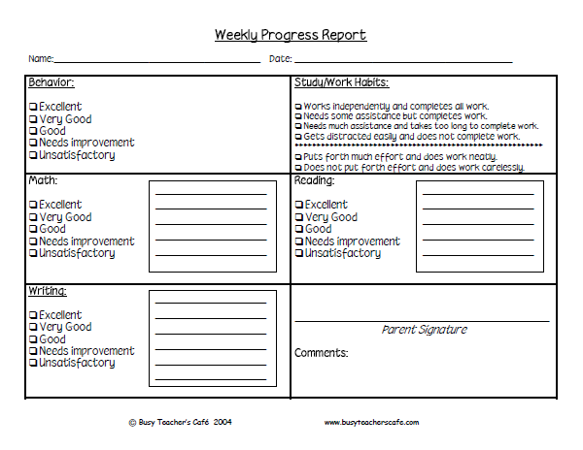

The chart above is a sample of a communication log that mentors can use to help parents keep track of academic goals and attendance.

