
Tip Sheet for Data Collection
Regular Positive Communication Behavior Strategies
If your Vital Behavior is: “Family and student will review behavior strategies listed on a behavior chart to guide ___ weekly conversations/activities and share progress and comments with teacher once a month.”
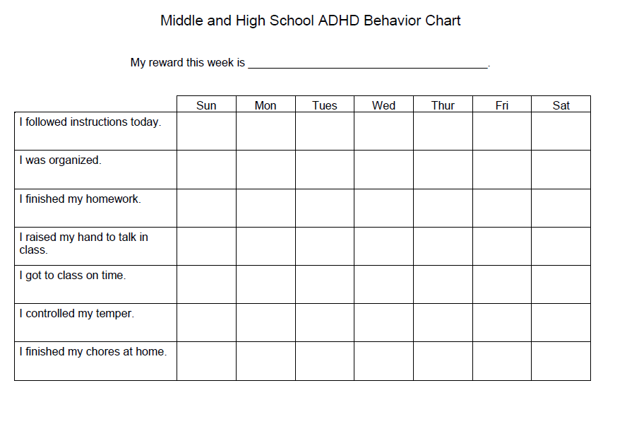
See more on Back
HINT:
This form was posted on a teacher blog. The teachers in your system may use a form already. Having a conversation with that teacher about what kind of communication they are using would be helpful. Then, you may choose to collaborate with the teacher to create a log of how parent is tracking behaviors at home.

The Pacer Center offers parents concise information on Behavior Strategies for home. Use this link for a one page guide:
http://www.pacer.org/parent/php/PHP-c218a.pdf

Here is a sample chart to help parents identify and track target behaviors:
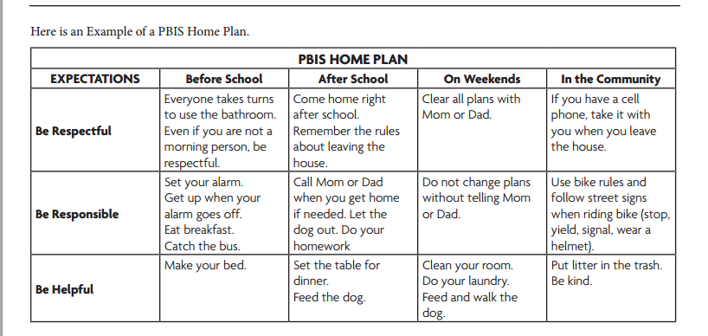
Today is: _________________________________________
Place a check in the box when this behavior is accomplished. Then, look back at the end of the day or week, or month and reward the accomplishments!

Parents can report progress from these home plan goals! Instant Data!

