
Tip Sheet for Data Collection
Regular Positive Communication Behavior Strategies
If your Vital Behavior is: “Family and student will review behavior strategies listed on a behavior chart to guide ___ weekly conversations/activities and share progress and comments with teacher once a month.”
Trusted Source: In order to create the most reliable evidence based data, it is helpful to use trusted sources. Below you will find resources from teacher websites and pinterest pages.
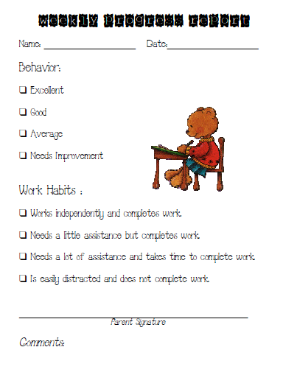
The behavior chart to the left is a version that was downloaded from a teacher Pinterest page.
Mentors can ask parents to document on a communications log based on the information they receive from school.
On the back of this sheet is another form of a behavior log designed for middle and high school students.

** Both of these forms can be downloaded to share with teachers by going to the Learning Curve.

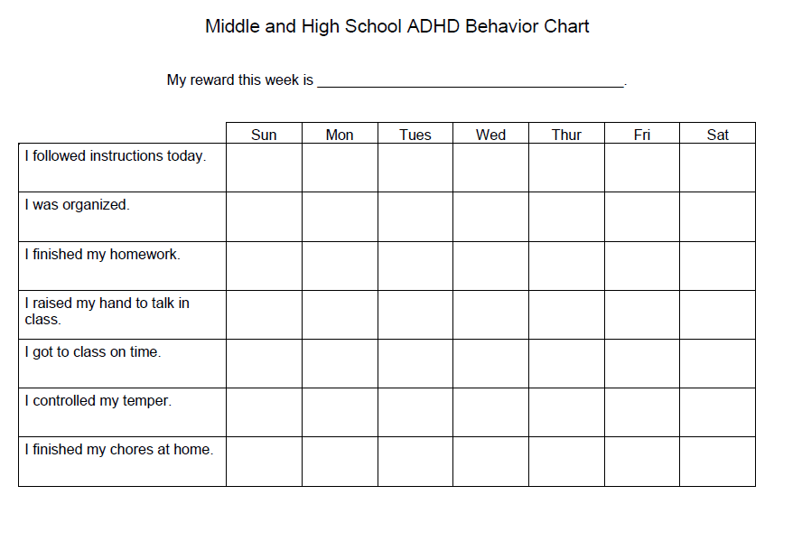

Need more help? Contact your region rep.

