
Tip Sheet for Data Collection
Regular Positive Communication Person Centered Planning
If your Vital Behavior is: “Family and student will participate in person centered planning and complete monthly task related to their plan and goals.”
The Pacer Center has several resources on Person Centered Planning : http://www.pacer.org/transition/learning-center/independent-community-living/person-centered.asp

Some steps (from the Pacer Center website) to get the family started: These tasks can be documented as action steps leading up to the PATH or MAP event.
- Develop a history or personal life story of the focus person. This is accomplished by everyone sharing past events in the person's life. The focus person's parents and family may share the largest amount of this information. Things such as background, critical events, medical issues, major developments, important relationships, etc., may be shared.
- Description of the quality of the focus person's life is shared next. This may be accomplished by exploring the following: Community participation, community presence, choices/rights, respect and competence.
- Personal preferences of the focus person. Things the focus person enjoys doing. Also including the things that are undesirable to the person.
The meeting to develop the personal profile usually occurs several days before the planning meeting so the participants have time to reflect on what is shared. The meeting, which takes about two hours, may use graphic symbols in place of words to help stimulate creativity and encourage participation.

The Next Step...the planning meeting

See a graphic explanation of the PATH on the back

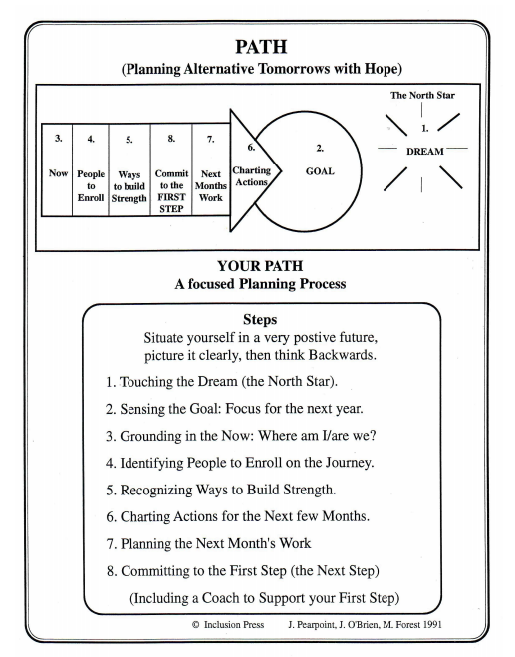

Ask a parent mentor: These parent mentors are experienced in person-centered planning: Wayne County April Lee, Hall County Scott Crain, White County Jane Grillo Houston County Marina Jones.

