
Tip Sheet for Data Collection
Regular Positive Communication Practice at Home
If your Vital Behavior is: “Use teacher provided exercise to practice at home at least 15 mins./ 2 times per week in an area of student’s need, supporting efforts to teacher using preferred method of communication.”
Trusted Source: In order to create the most reliable evidence based data, it is helpful to use trusted sources. Below you will find two ideas that utilize trusted sources:
From the Association of Supervision and Curriculum Development http://www.ascd.org/ascd-express/vol9/905-vatterott.aspx Mentors can make a flyer identifying the guidelines below to share with parents and use these as survey questions to help parents choose goals.
Suggested Guidelines for Parental Involvement in Homework
Parents are encouraged to …
- Ask their child about what the child is studying in school.
- Ask their child to show them any homework assignments.
- Assist their child in organizing homework materials.
- Help their child formulate a plan for completing homework.
- Provide an appropriate space for their child to do homework.
Parents may, if they wish …
- Help their child interpret assignment directions.
- Proofread their child's work, pointing out errors.
- Read aloud required reading to their child.
- Give practice quizzes to their child to help prepare for tests.
- Help their child brainstorm ideas for papers or projects.
- Praise their child for completing homework.
Parents should not …
- Attempt to teach their child concepts or skills the child is unfamiliar with.
- Complete assignments for their child.
- Allow their child to sacrifice sleep to complete homework.
References Goldberg, K. (2007, April). The homework trap. Paper presented at the annual meeting of the American Educational Research Association, Chicago.
See Back for another data collection resource
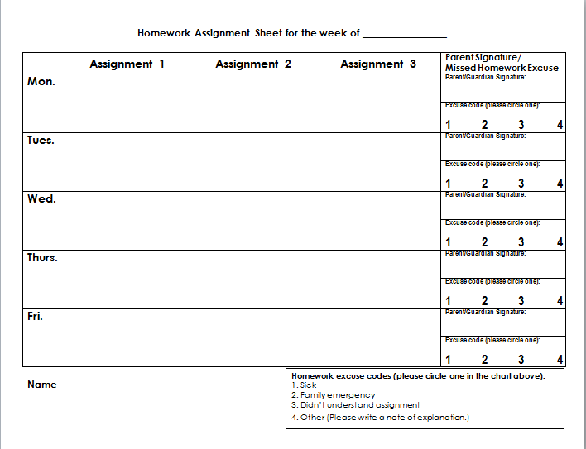

Parents can track how often and when they helped with homework, or met one of their work at home goals. This form can be downloaded from the Learning Curve

