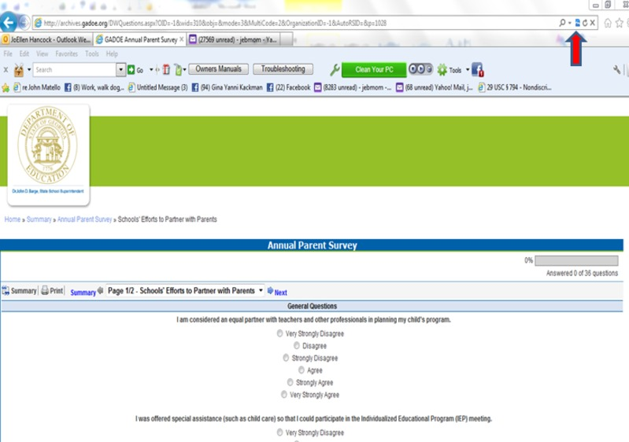

It is NOT the link...it is a compatibility issues.
Here is how you fix that
Click on the link.
Click on begin.
Once you have the survey up on the first page, go to the very top where your browser is (the URL is in the box).Go all the way to the right hand side. You will see a magnifying glass, an arrow and the a symbol that looks like a torn piece of paper.
Click on that. That is the compatibility button that will automatically sync in order to let you do the survey on line
Submitted by Joellen Hancock Cherokee County Schools Parent Mentor

