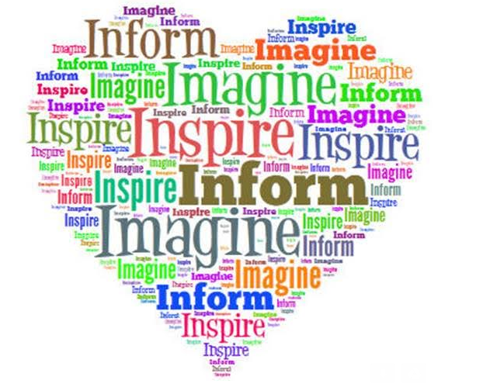
Inform, Imagine and Inspire
Kickoff 2015
Speakers and Experts
Links and Resources to learn more about these topics
C.A.F.E. Circles of Adults Focused on Education
http://www.baker.k12.ga.us/?PageName=LatestNews&Section=Highlights&ItemID=199148&ISrc=School&Itype=Highlights&SchoolID=895
http://www.gaspdg.org/sites/www.gaspdg.org/files/resources/documents/cafe_manual_cds_8-22-13_final.pdf

Georgia Academy for the Blind Chorus
https://www.facebook.com/Georgia.Academy.for.the.Blind/videos/407140526048010/
http://www.gabmacon.org/pages/Georgia_Academy_for_the_Blind

Matthew and Suzanne Dooley
http://www.matthewdooleyspeaks.com/

