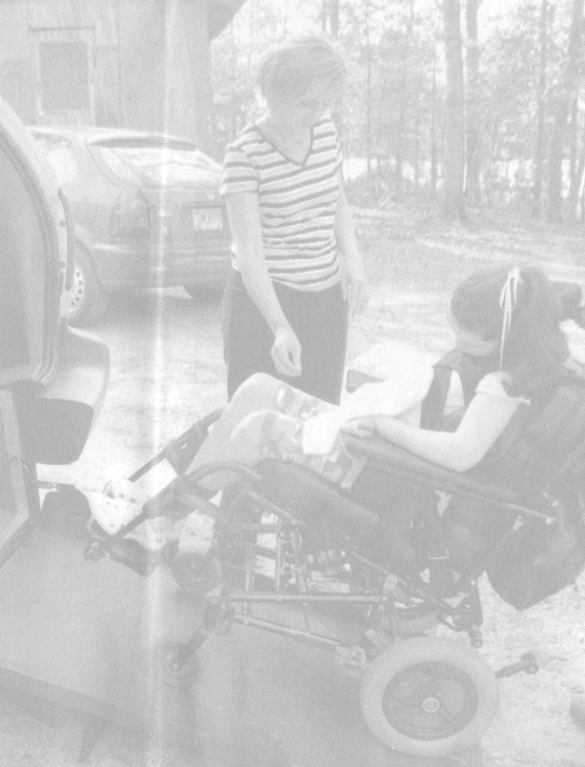

July 10, 2008

To Our Dear Friends,
Callie and I send our most sincere thanks for your help with the van purchase. Because of your generous contribution, we were able to buy a 2007 Dodge Caravan that is in perfect condition. And what a difference having this van has made in our lives!

The rear floor of the van is lowered to accommodate a fold-out ramp. Callie’s wheelchair rolls to a stop between two seats and is tied down to the floor with retractable hooks. For Callie’s first social outing with her new van, she invited two girls from school to go to the mall. It was exciting for her
to be able to ride with a friend on either side for the first time!

The rear entry is very convenient because we don’t need a lot
of space at the side to load and unload; sometimes we don’t even
need to use a handicap parking space. The ramp is easy to operate,
and the van gets surprisingly good gas mileage.

I knew the Lord would supply our need, and I appreciate your willingness to bless Callie and me. Travel is not a chore anymore!

Forever Grateful,

P.S. Shortly after we got the van, I had to have surgery that prevented me from lifting Callie for six weeks. What a timely gift this truly was!

