**Featured Speakers**

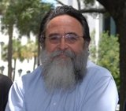**Tom Kohler**

**Waddie Welcome and the Beloved Community**

Tom Kohler’s involvement with people with disabilities and Citizen Advocacy began long before he and Susan Earl began writing “Waddie Welcome and the Beloved Community”.

 His first involvement with someone with a disability was as a volunteer in his Temple Youth Group at Mickve Israel Temple. This influenced the remainder of his school and work life. He is a native of Savannah and a 1970 graduate of Jenkins H.S. He attended Armstrong State College and graduated from UGA in 1976.  He is the father of 2 remarkable young women, Alice, a 7th grade public school teacher here in Savannah, and Lucy, who is in the Peace Corps in Tanzania.

 Tom has served as the coordinator of Chatham Savannah Citizen Advocacy for nearly 40 years. This work has involved meeting, listening to, talking with, and involving thousands of people from all walks and wheels of life in one another’s lives.

“Waddie Welcome and the Beloved Community” has grown beyond its printed page. It has been adapted as a stage play at the Emery Theatre in Cincinnati, Ohio. It has been read on MLK Day throughout the world. Tom and New York based artist Beth Mount recently produced the exhibit “Journey toward the Beloved Community” at the Jepson Museum in Savannah.”

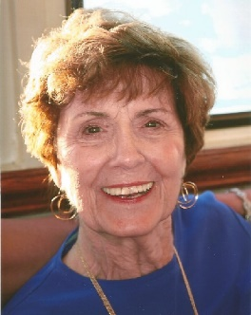**Irene Lester**

**Along Came Bill**

Irene Lester was born in Chicago, Illinois and attended Chicago public schools and the University of Illinois where she graduated with a degree in Special Education, elementary level.

After three years of teaching in Harvey, Illinois, Irene moved to Atlanta, Georgia where she taught third grade, met and married Lamar Lester and began her family. First came son Lamar, Jr., then daughter Sissy (Laura) and in 1970 along came Bill. The Lesters welcomed their third child, Bill, who had many challenges that bewildered the family and his doctors.

The family relocated to Savannah when Bill was eight years old and Irene, in an effort to learn more about how to support Bill, entered school to continue her study of special education at Georgia Southern University. She went on to earn a Masters' Degree in Education and a second Masters' in School Counseling.

“It is Bill's story that I wish to share with you and other parents who find themselves raising a child with disabilities and problems they are not fully prepared for and do not understand.”

**Featured Speakers**

**Georgia Vocational Rehabilitation E3 Team**

**The Stars are Aligning for Georgia**

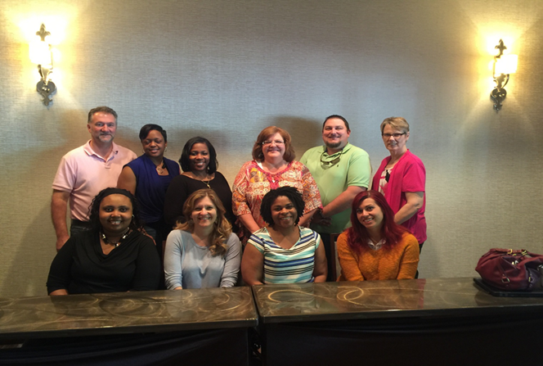

The GVRA E3 team will present exciting information about the bright future for employment opportunities for students and young adults with disabilities.

Georgia’s Career Pathways to Work: Explore, Engage and Employ (E3)

* $4.7 Million over 5 years has been awarded by the US Department of Education.
* Working in partnership with Georgia Department of Education, Poses Family Foundation, and Georgia State University Center for Leadership in Disability, Burton Blatt Institute at Syracuse University and Southeast ADA, Parent to Parent of Georgia and Georgia Workforce Development.
* 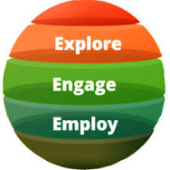Will focus on youth ages 14-24 both in and out of school.
* Will transform the way that GVRA is engaging students and youth with disabilities in transitioning to careers.

**Allyson Harvin & Kevin Horton**

**Night of Champions**

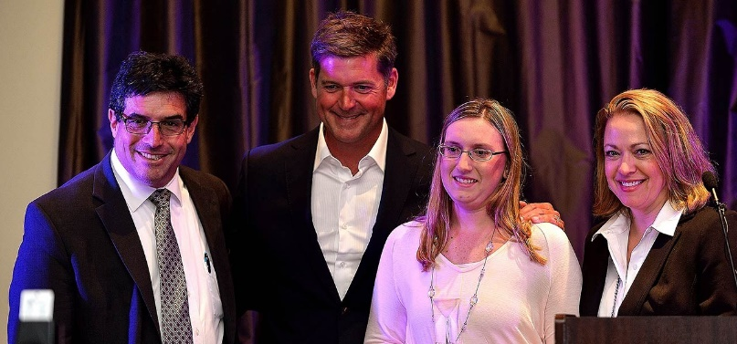According to the National Down Syndrome Congress, as many as eighty percent of adults with Down syndrome are unemployed. Low expectations and a lack of understanding about the great skills and wonderful work ethic many people with Down syndrome possess have contributed to this sad statistic. Lowcountry Down Syndrome Society (LDSS) hopes to reverse this trend by encouraging area employers to give differently abled workers a chance.

Each May LDSS hosts an annual Night of Champions. This community event recognizes area businesses that employ differently abled adults, including those with Down’s syndrome, and celebrates the contributions made by these employees.

“Dignity and self-respect are borne out of feeling that what we have to offer makes a difference,” said LDSS Night of Champions Chairperson, Allyson Harvin. “When forward thinking businesses give those with Down syndrome, and other differently abled adults, a chance to be productive members of society, society itself benefits.”