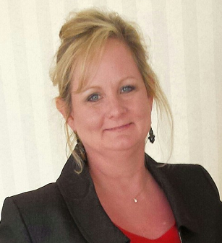  Kathy Simmons  Dodge  LC past chair  Region Rep | 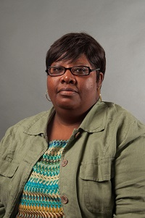  Donna James  Baldwin | 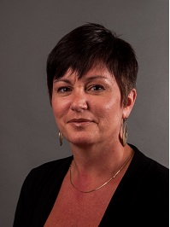  Terri Goodridge  Bibb | 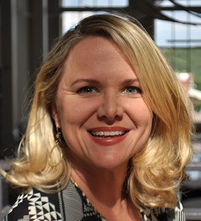  Jennifer Minter  Bibb |   Michele Olandez  Crawford | 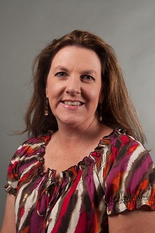  Allison Stevenson  Fayette  LC past chair | 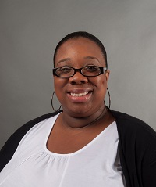  Taka Taylor  Hancock | 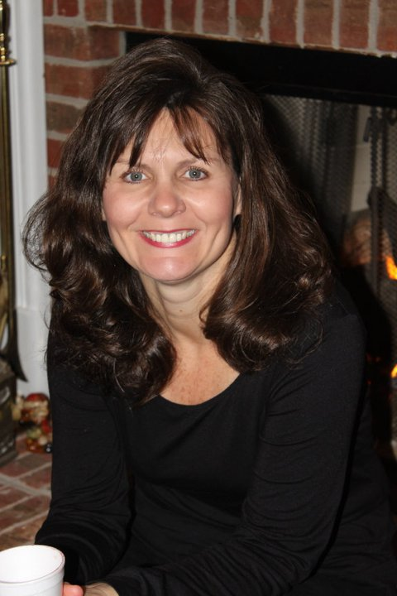  Carolyn Heard  Henry
Cindy Clendenis  Jasper | 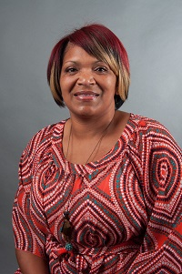  April Wooten  Jones  LC |   Marina Jones  Houston |   Regina Lindsey  Johnson | 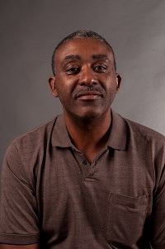  James Butler  Lamar | 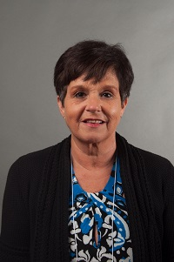  Ginger Henderson Meriwether | Beth Smith  Monroe | Matt Reese  Montgomery
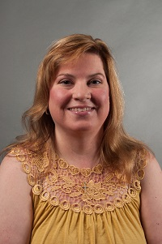  A.Diane Johnson  Newton  LC | 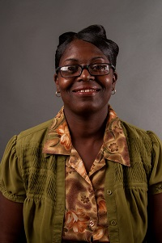  Cynthia Criss  Pulaski  LC | 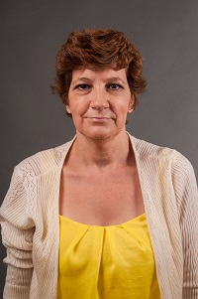  Dayna Moeller  Putnam | 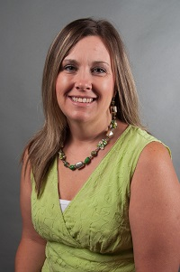  Taimie Hoffman  Thomaston Upson | Barbara Bryant  Twiggs | 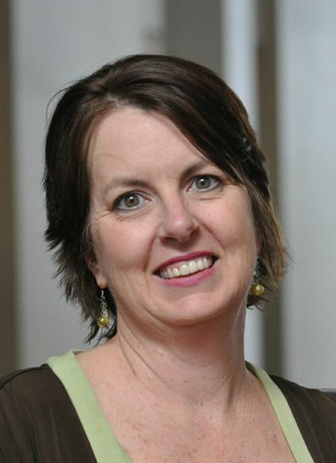  Sonya Milam  Ga. Academy for the Blind | Always room for more | Always room for more

