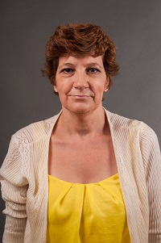  Dayna Moeller  Putnam  Region Rep | 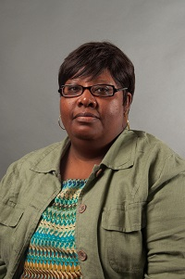  Donna James  Baldwin | 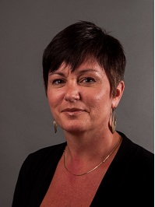  Terri Goodridge  Bibb | 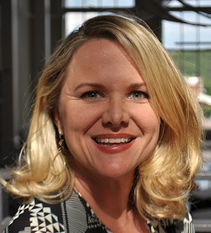  Jennifer Minter  Bibb |   Michele Olandez  Crawford | 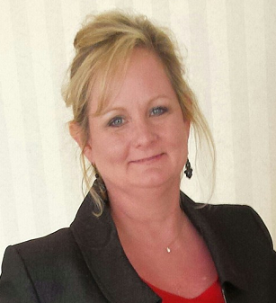  Kathy Simmons  Dodge  LC past chair | Open  Fayette | 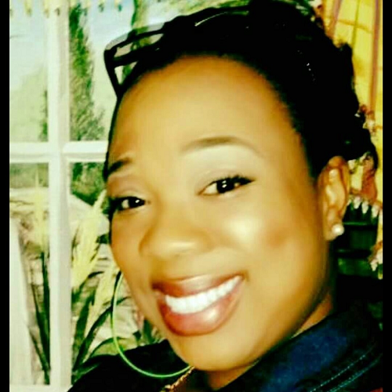  Taka Taylor  Hancock
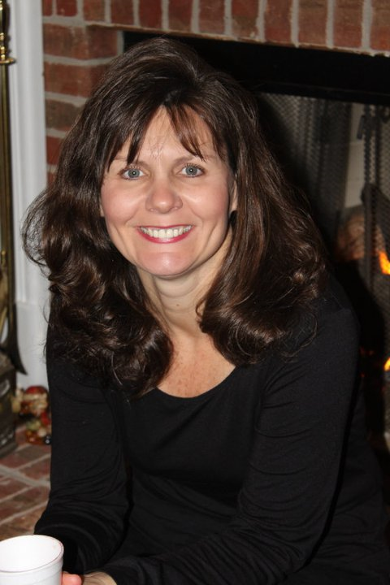  Carolyn Heard  Henry | 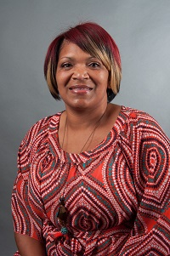  April Wooten  Jones  LC Chair | 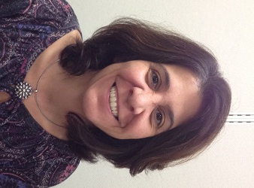  Marina Jones  Houston | 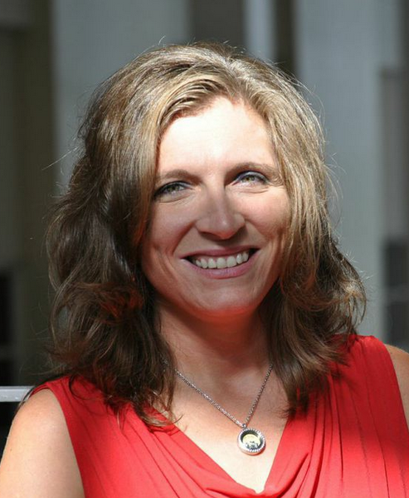  Regina Lindsey  Johnson | 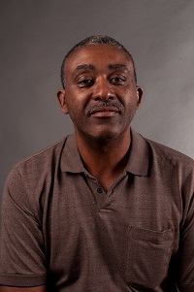  James Butler  Lamar | 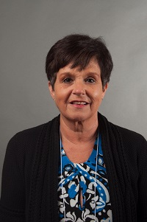  Ginger Henderson Meriwether | Beth Smith  Monroe | Matt Reese  Montgomery
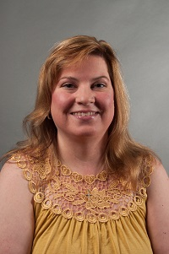  A.Diane Johnson  Newton  LC | 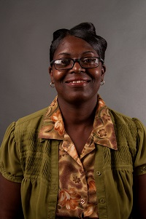  Cynthia Criss  Pulaski  LC | Together  We Can | Open  Thomaston Upson | 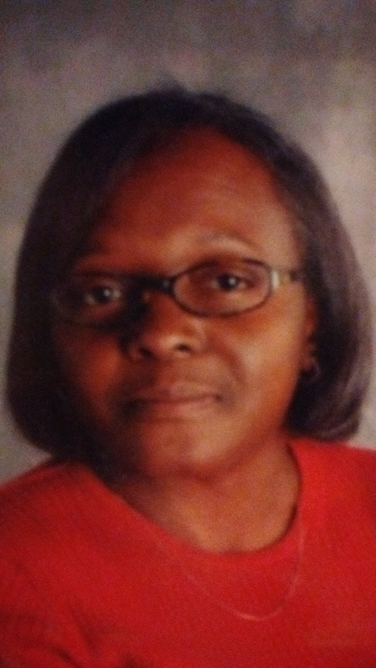  Barbara Bryant  Twiggs | 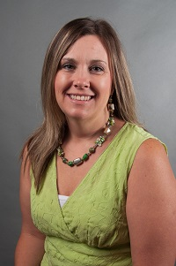  Taimie  Hoffman  Wheeler | 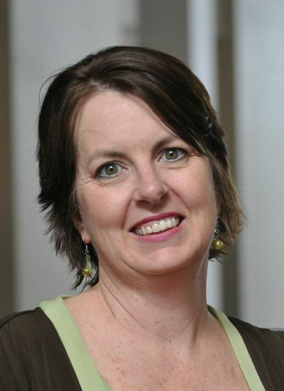  Sonya Milam  Ga. Academy for the Blind | Always room for more

