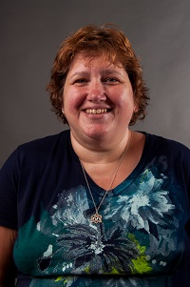  Jodie Zeuke  Oglethorpe Region Rep | 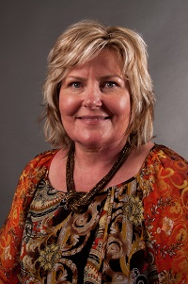  Mellie Caudell  Banks | 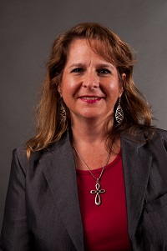  Cyndi White  Barrow  LC past chair | 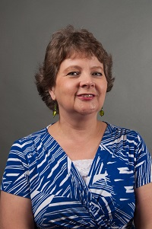  Jerolee Oschack  Clarke | 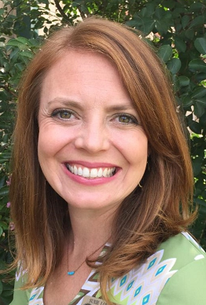 Susie Lovekamp  Columbia |   Open  Elbert | Open  Habersham | 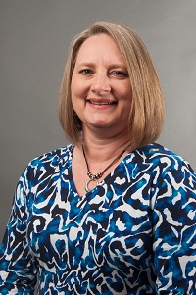  Teresa Bruce  Franklin
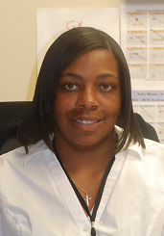  Jacqueline Evans  Greene County | 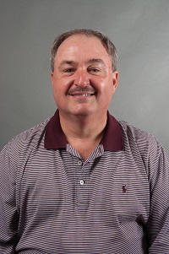  Scott Crain  Hall  LC past chair | 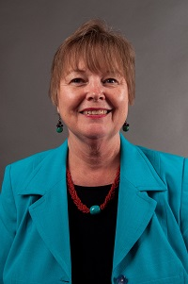  Marsha Sahlman  Hart | 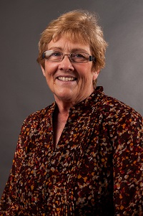  Barbara Bosanko  Lumpkin | 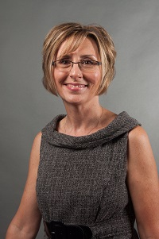  Pam Walley  Madison  LC past chair | 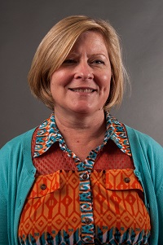  Amy McCollum  Oconee  LC Chair | Open  Rabun | 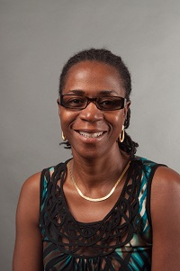  Cassandra Stone  Richmond
Open  Richmond | 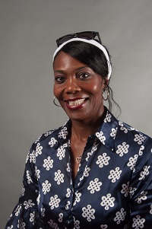  Annetta Mayfield  Stephens | 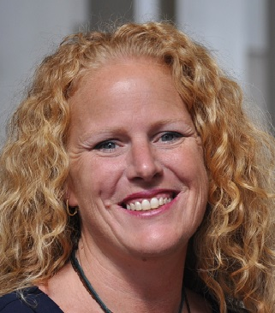  Becky Tracy  Union | Bonnie Morris  Walton | 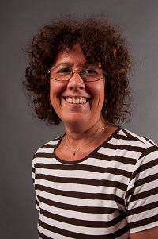  Jane Grillo  White | 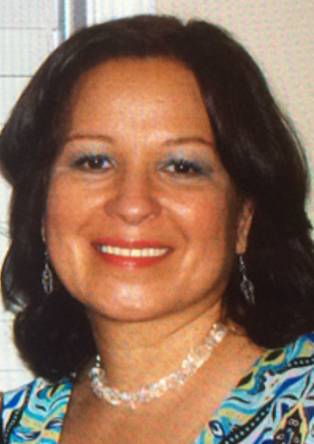  Maritza Rivera  Gainesville City | Always room for more | Always room for mere

