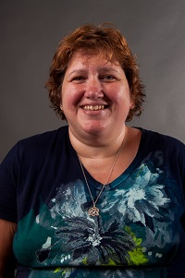  Jodie Zeuke  Oglethorpe Region Rep |   Open  Banks | 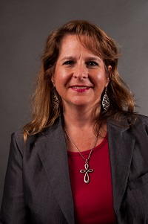  Cyndi White  Barrow  LC past chair | 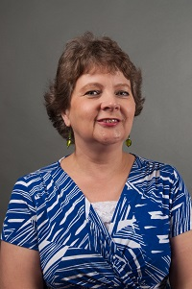  Jerolee Oschack  Clarke | Latoya Roper  Columbia | Open  Elbert | Open  Habersham | 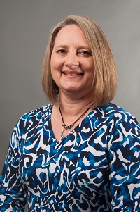  Teresa Bruce  Franklin
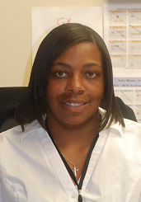  Jacqueline Evans  Greene County | 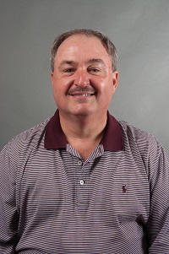  Scott Crain  Hall  LC past chair | Open  Hart | Open  Lumpkin | 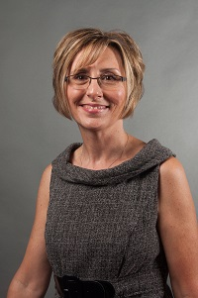  Pam Walley  Madison  LC past chair | 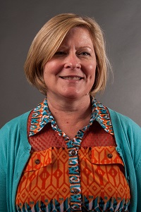  Amy McCollum  Oconee  LC past chair | Open  Rabun | 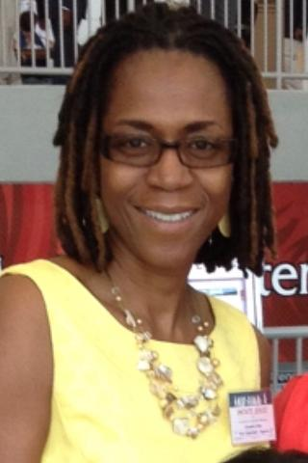  Cassandra Stone  Richmond
Open  Richmond | Lori Rose  Stephens | 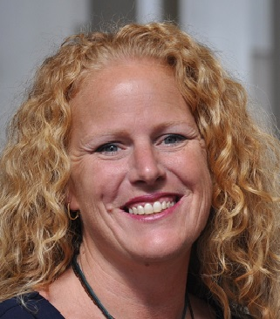  Becky Tracy  Union | 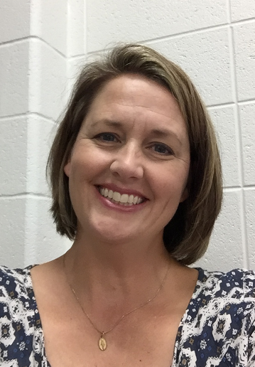  Bonnie Morris  Walton | 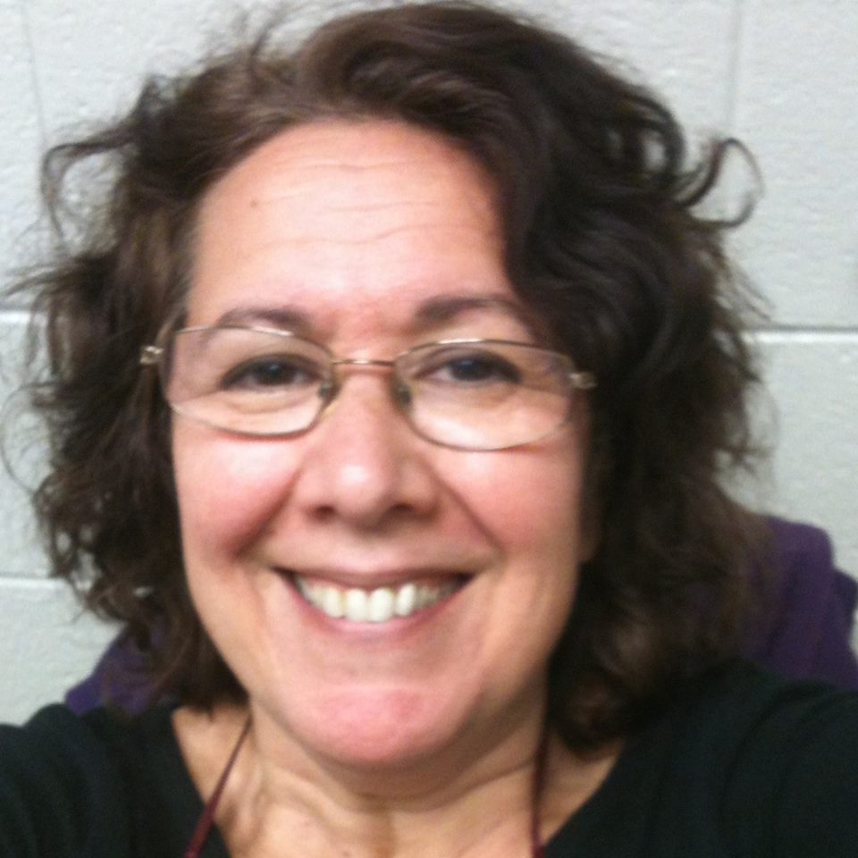  Jane Grillo  White | Open  Gainesville City | Always room for more | Always room for mere

