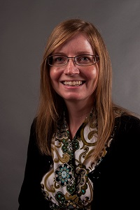  Renee Davis  Douglas  Region Rep | 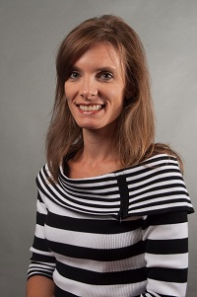  Kim Chester  Bartow |   Open  Catoosa | 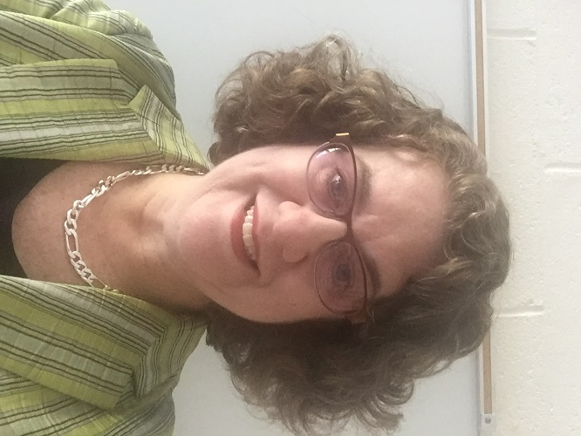  Georgia Fruechtenicht  Coweta | 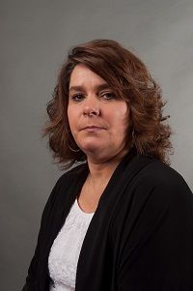Cynthia Daniels  Dade | Together We Can | 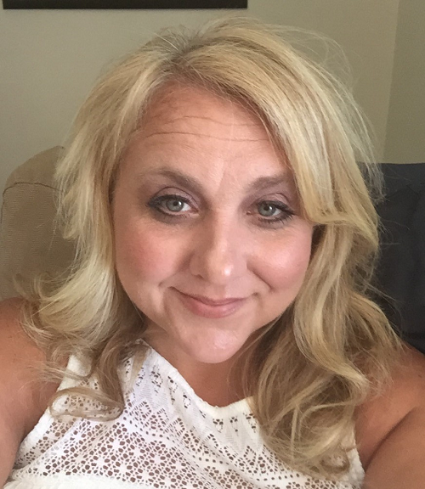  Brandi Waters  Gordon | 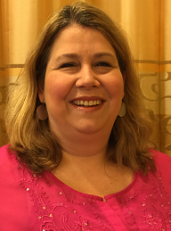  Angela West  Haralson
Together We Can | 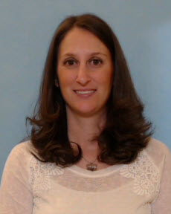Amy Pitts  Paulding | 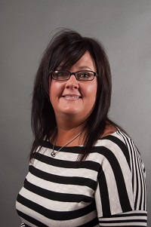  Tracy Reynolds  Polk | 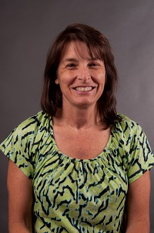  Jodie Mazzolini  Troup | 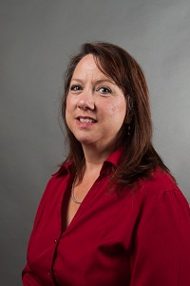  Michal Jones  Walker | 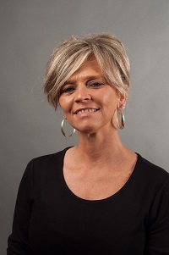  Erin Arledge  Whitfield | Open  Dalton City | 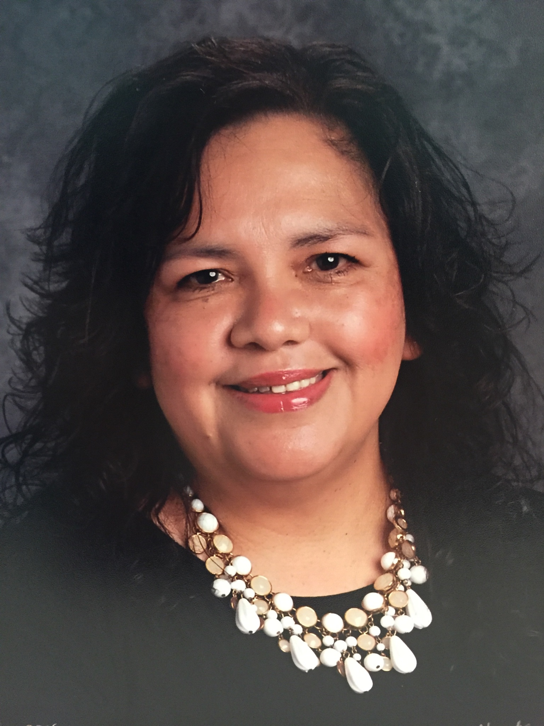  Cecilia Trejo  Calhoun City
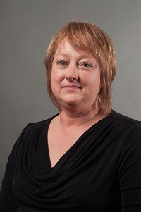  Linda Young  Trion City | Always room for more | Always room for more e | Always room for more | Always room for more | Always room for more | Always room for more | Always room for mere

