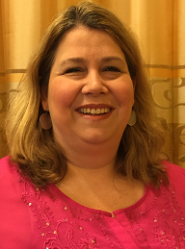  Angela West  Haralson  Region Rep | 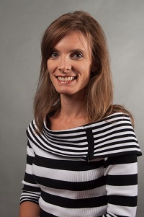  Kim Chester  Bartow |   Open  Catoosa | 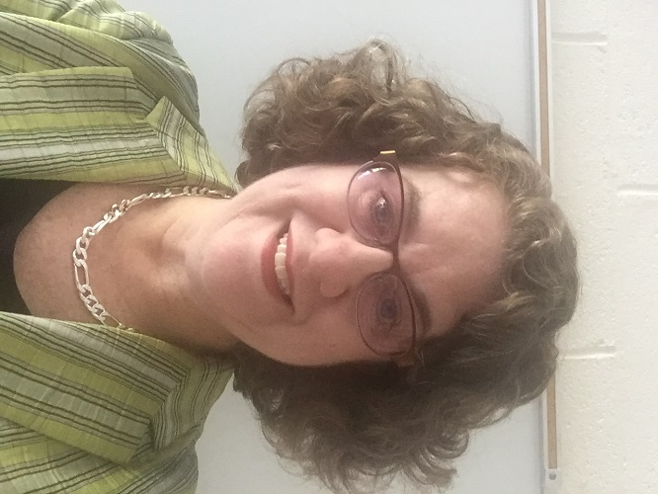  Georgia Fruechtenicht  Coweta | 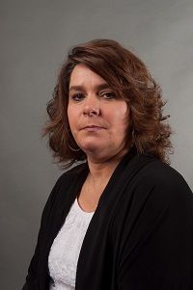  Cynthia Daniels  Dade |   Brandi Waters  Gordon | Open  Paulding | Together  We Can
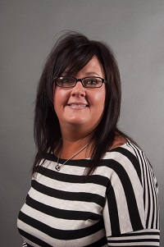  Tracy Reynolds  Polk | 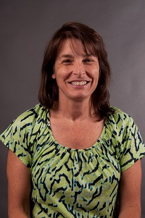 Jodie Mazzolini  Troup | 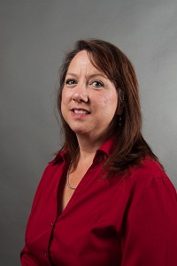  Michal Jones  Walker | 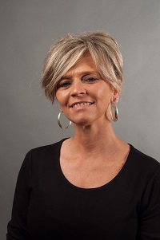  Erin Arledge  Whitfield | Open  Dalton City | Marie Funes  Calhoun City | 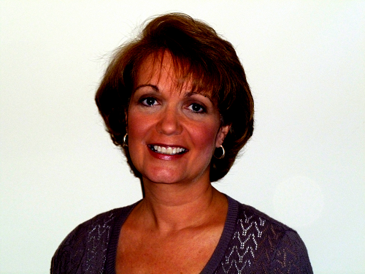  Missy Sullivan  Carrollton City | Caroline Threadgill  Rome City
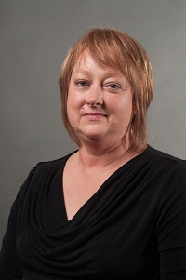
Linda Young
Trion City

