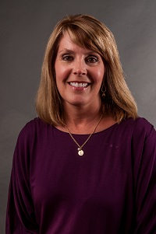  Lori Bonds  Emanuel  Region Rep | 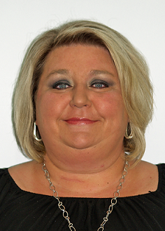  Karen Tharpe  Appling |   Open  Brantley | Celena Hughes  Bryan | 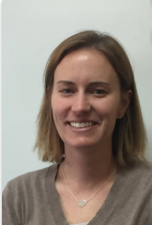  Fay Blythe  Bulloch | 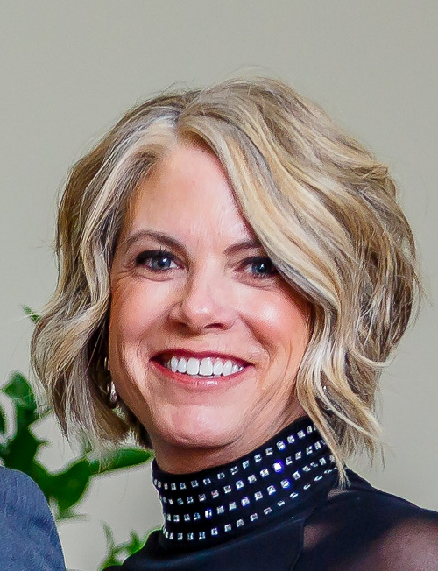  Jincy Fordham  Candler | 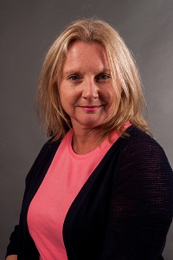  Julie Hardeman  Chatham | Irris Wallace  Chatham
Always room for more | 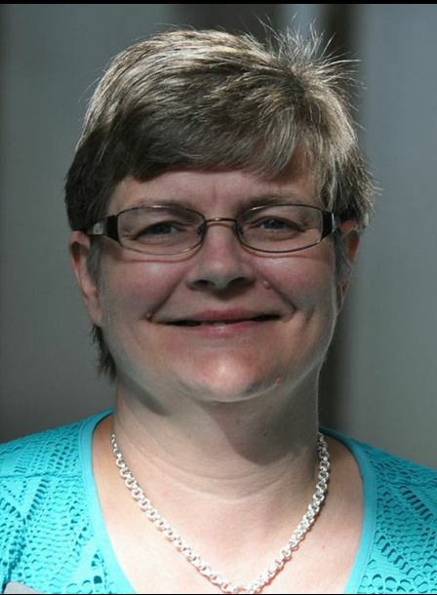  Amy Ambrose  Effingham | 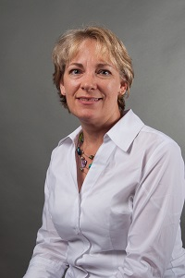  Amanda Locke  Evans | 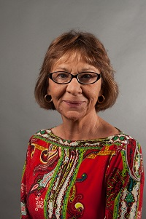  Shirley Moore  Glynn | 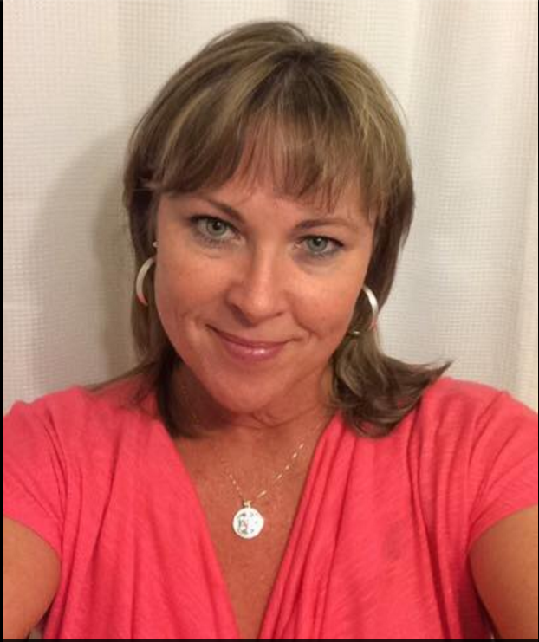  Lisa Vaughn  Liberty | Matt Reese  Montgomery | 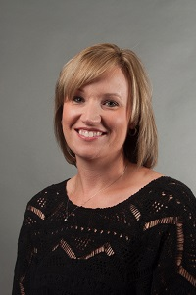  Kristi Murphy  Pierce | 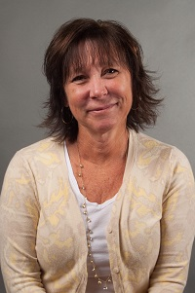  Kim Gibson  Ware
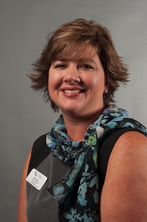  April Lee  Wayne  LC past chair | Contina Smith  Valdosta City | Always room for more | Always room for more | Always room for more | Always room for more | Always room for more | Always room for mere

