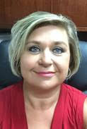  Karen Tharpe  Appling  Region Rep |   Open  Brantley | Celena Hughes  Bryan | 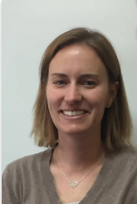  Fay Blythe  Bulloch | 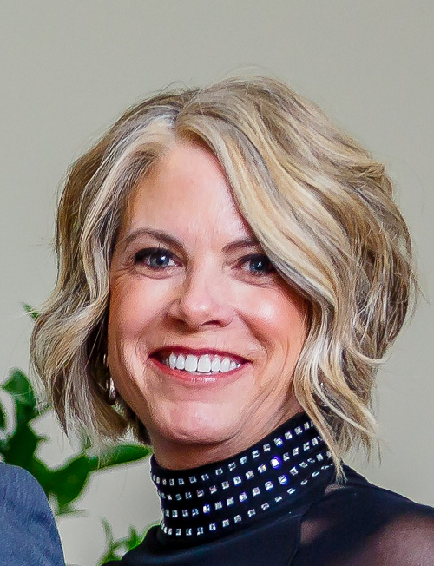  Jincy Fordham  Candler | 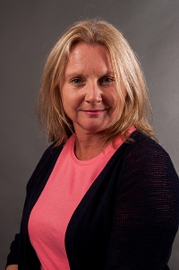  Julie Hardeman  Chatham | Letisha Bready  Chatham | Together  We  Can
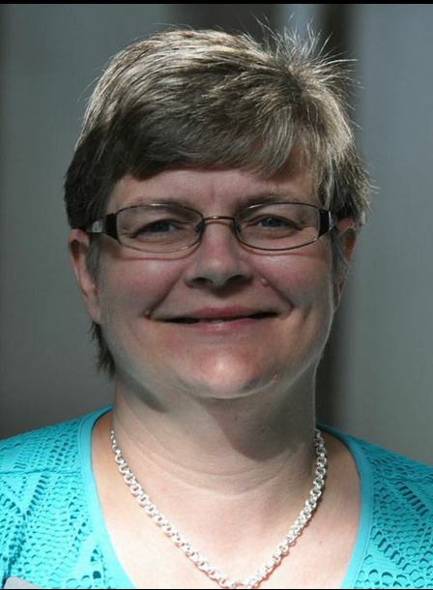  Amy Ambrose  Effingham | 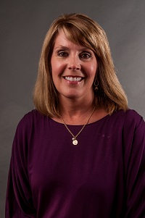  Lori Bonds  Emanuel | 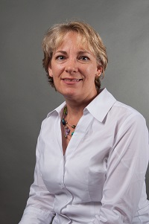  Amanda Locke  Evans | Billie Foulk  Glynn | Tomesha Giddings  Liberty | 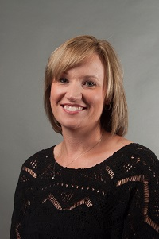  Kristi Murphy  Pierce | 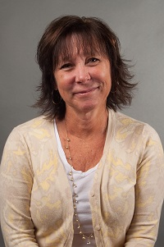  Kim Gibson  Ware | Open  Wayne

