  Shanitha Jones  Marion  Region Rep |   Shamika Reed  Baker | Open  Calhoun | Open  Decatur | 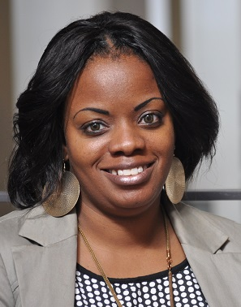 Kristi Hodge  Dougherty | 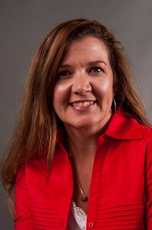  Rebecca Best  Grady | 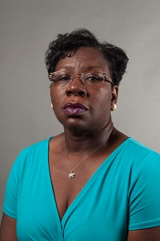  Shirley Daniels  Mitchell | 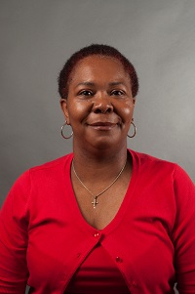  Latonia Mansfield  Terrell
  Tiffany Ross  Seminole | A’Kimberly Jones  Stewart | Open  Sumter | 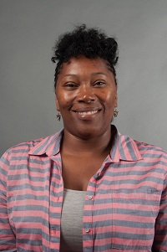  Felisha Draggs  Pelham City | 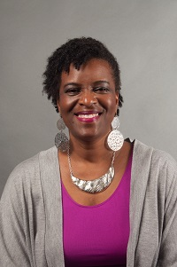  Deborah Bryant  Thomasville City | 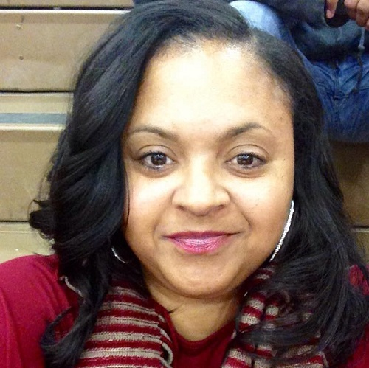  Contina Smith  Valdosta City | Always room for more | Always room for more
Always room for more | Always room for more | Always room for more e | Always room for more | Always room for more | Always room for more | Always room for more | Always room for mere
Meeting Dates:

Sept. 2, 2015
Nov. 4, 2015
Jan. 6, 2016
March 2, 2016
May 4, 2016

