  Shanitha Jones  Marion  Region Rep |   Shamika Reed  Baker | Open  Calhoun | Open  Decatur | 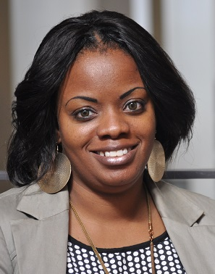 Kristi Hodge  Dougherty | 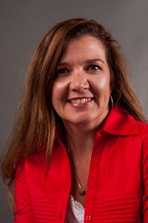  Rebecca Best  Grady | 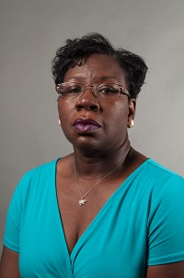  Shirley Daniels  Mitchell | 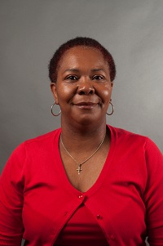  Latonia Mansfield  Terrell
  Tiffany Ross  Seminole | 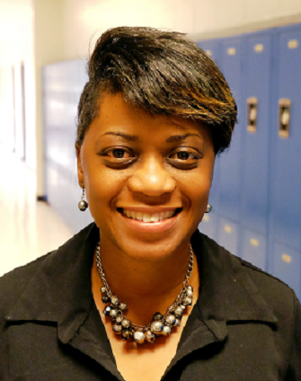  A’Kimberly Jones  Stewart | Open  Sumter | 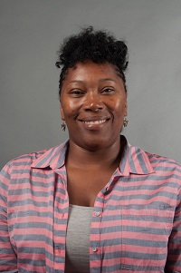  Felisha Draggs  Pelham City | 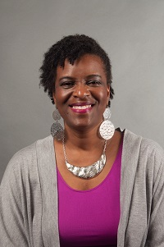  Deborah Bryant  Thomasville City | 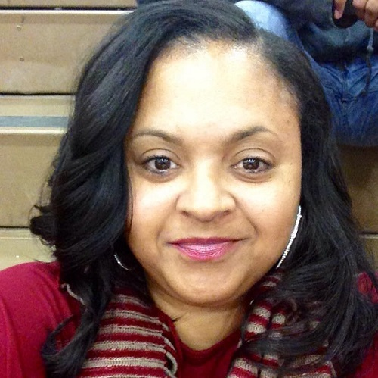  Contina Smith  Valdosta City | Always room for more | Always room for more
Always room for more | Always room for more | Always room for more e | Always room for more | Always room for more | Always room for more | Always room for more | Always room for mere

