  Shanitha Jones  Marion  Region Rep | 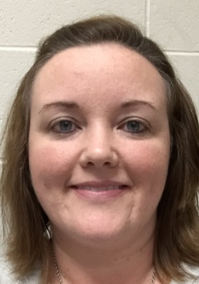  Naomi Ammenhauser  Baker |   Melissa Ragan  Calhoun | 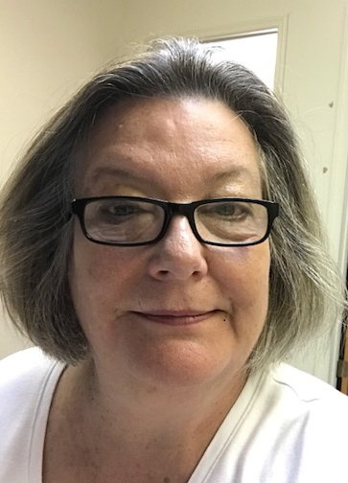  Kit Griffin  Decatur | 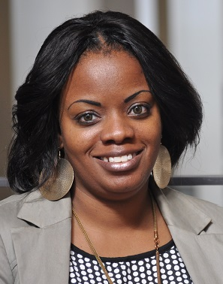 Kristi Hodge  Dougherty |   Rebecca Best  Grady | 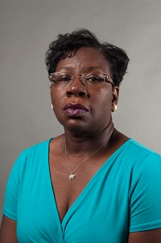  Shirley Daniels  Mitchell | 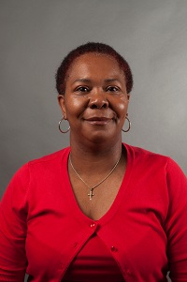  Latonia Mansfield  Terrell
  Tiffany Ross  Seminole | 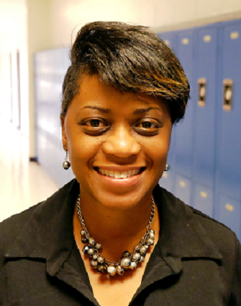  A’Kimberly Jones  Stewart | Open  Sumter | Bernadette Bennett  Pelham City | 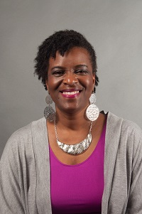  Deborah Bryant  Thomasville City |   Contina Smith  Valdosta City | Always room for more | Always room for more

