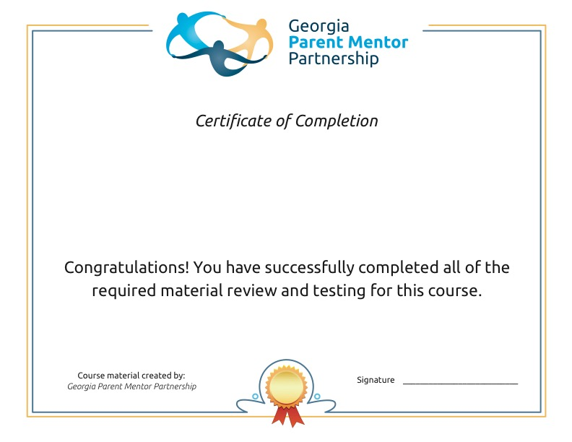
Learning Strategies for Parents
Course material created through a collaborative project of the Marcus Institute, the Ga. Dept. of Education SPDG and the Georgia Parent Mentor Partnership

