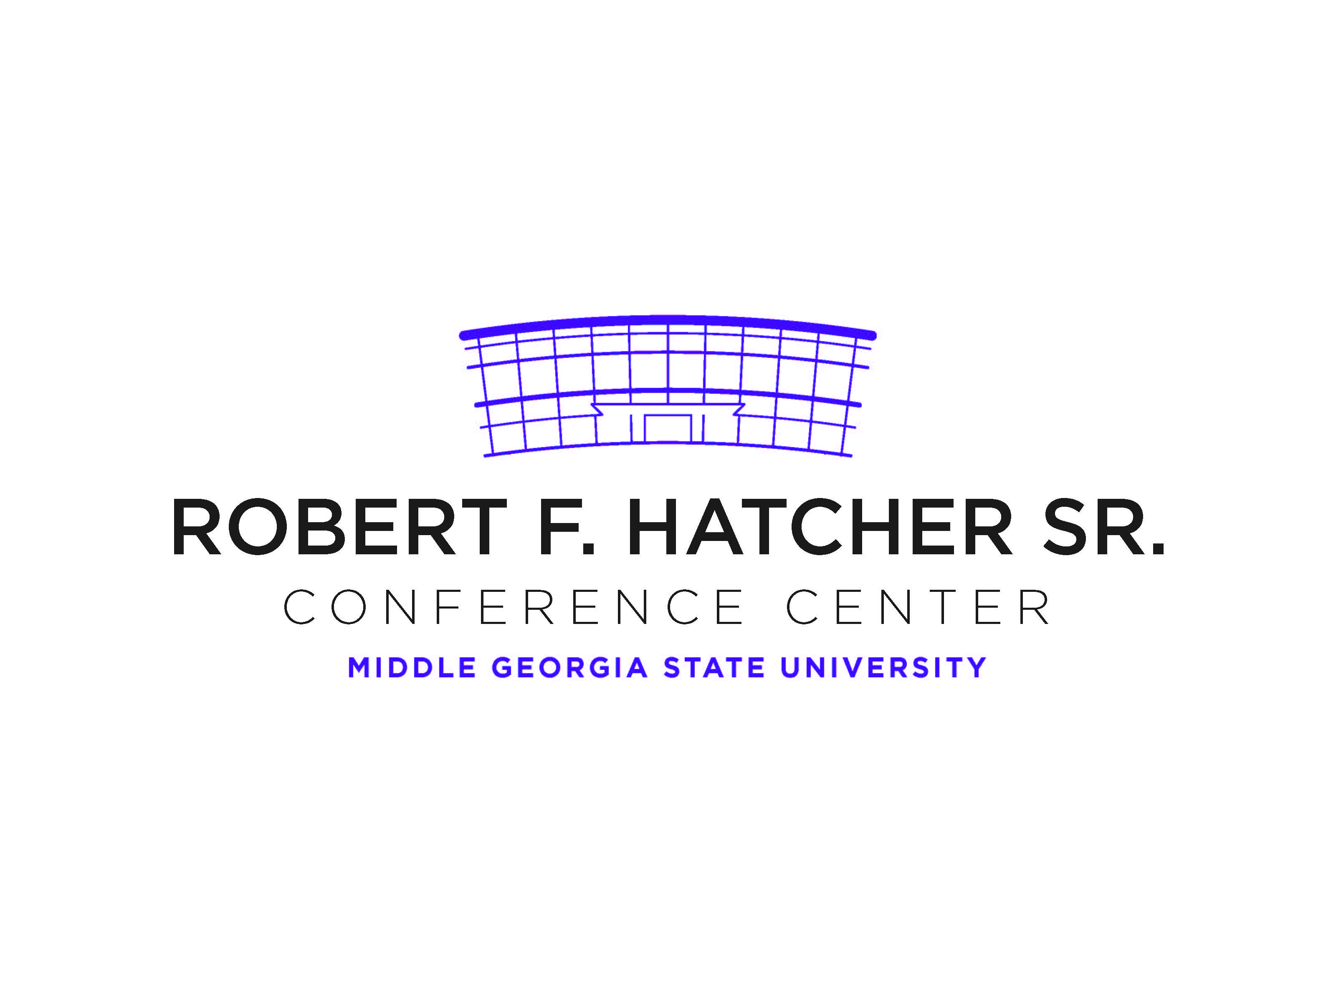

**TEMPORARY PARKING PERMIT**

***VALID DATE: September 14, 2023***

**FY 2024 Parent Mentor Kickoff Meeting**

DO NOT PARK IN FACULTY/STAFF PARKING AREAS.

DO NOT BACK INTO SPACE

DISPLAY PERMIT ON DASHBOARD OR REAR WINDOW

Smoking is prohibited on campus