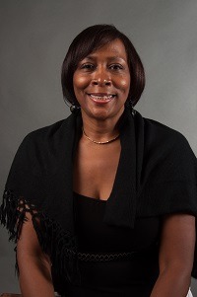  Edith Abakare  Atlanta City  Region Rep | 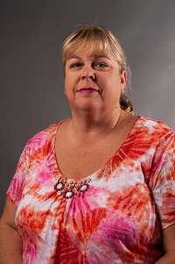  Sharon Hall  Cherokee | JoEllen Hancock  Cherokee  LC Sunshine Fund | Sharanda Johnson  Clayton | Open  Clayton | 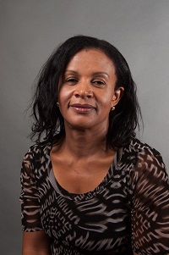Ijeoma Ajoku Cobb | Open  Cobb | 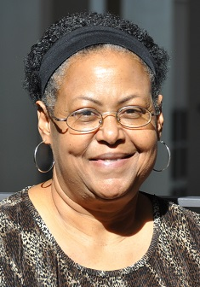  Linda Earley Williams  DeKalb
Together  We Can | 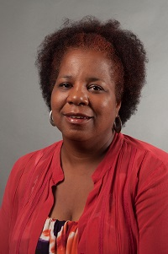  Sabrinia Gresham  Fulton | 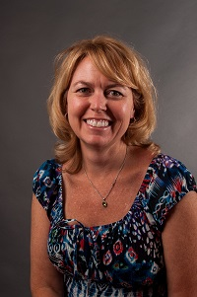  Patti Grayson  Fulton | 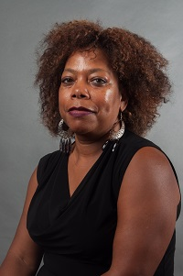  Jackie McNair  Gwinnett | 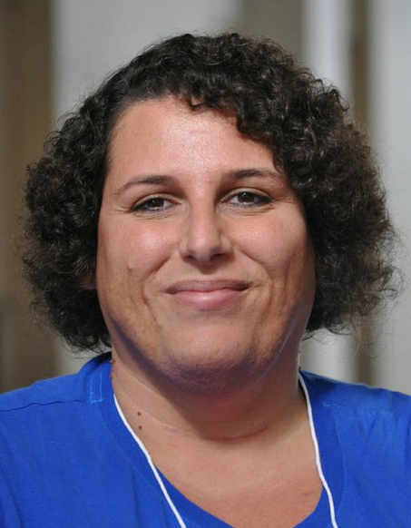  Dawn Albanese  Gwinnett | 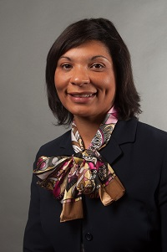  Vernita Harris  Muscogee | 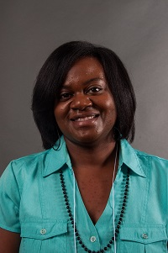  Lakisha Smith  Muscogee | 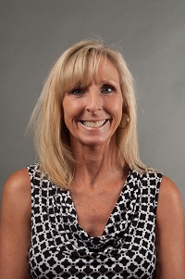  Caroline Hill  Rockdale
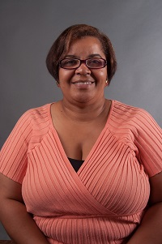  Rose Calloway  Atlanta City | 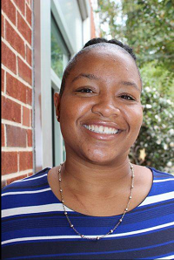  Cheryl Grant  Decatur City | 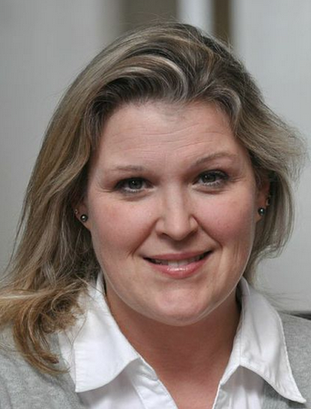  Ashley Gellis  Marietta City | 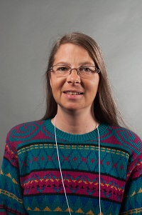  Jennifer Anderson  Ga Cyber  Academy | Open  Atlanta Area School for the Deaf | Always room for more | Always room for more | Always room for mere

