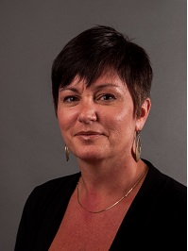  Terri Goodridge  Bibb  Region Rep | 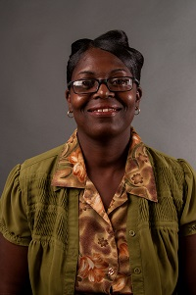  Cynthia Criss  Pulaski  Assistant Region Rep | 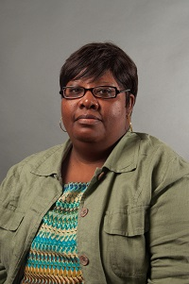  Donna James  Baldwin | 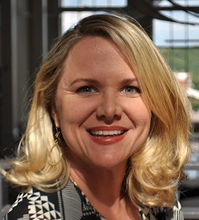  Jennifer Minter  Bibb | 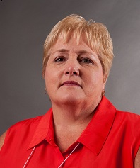  Cheryl Whitaker  Crawford | 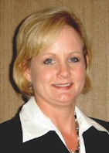  Kathy Simmons  Dodge  LC Past Chair | 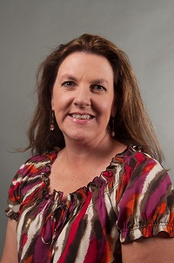  Allison Stevenson  Fayette  LC Chair | Open  Greene
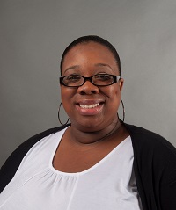  Taka Taylor  Hancock | Carolyn Heard  Henry | 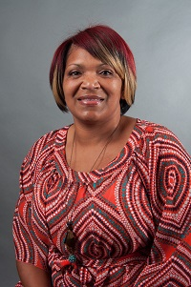  April Wooten  Jones  LC Vice Chair | Cindy Clendenis  Jasper | 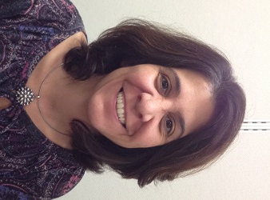  Marina Jones  Houston | 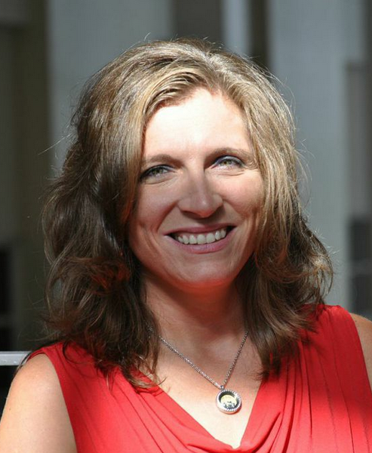  Regina Lindsey  Johnson | 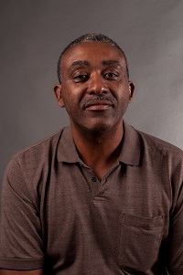  James Butler  Lamar | 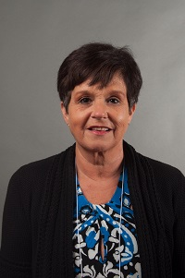  Ginger Henderson Meriwether
Open  Monroe | 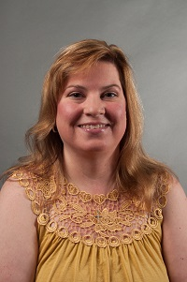  A.Diane Johnson  Newton | 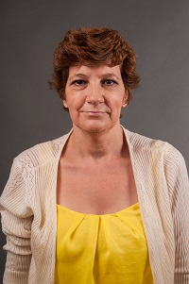  Dayna Moeller  Putnam | 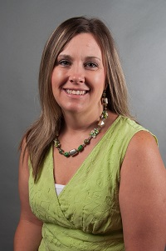  Taimie Hoffman  Thomaston Upson | 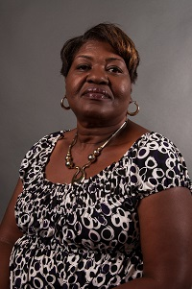  Bessie Bonds  Twiggs | 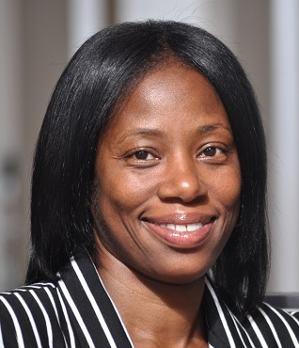  Doricia Thompson  DJJ | 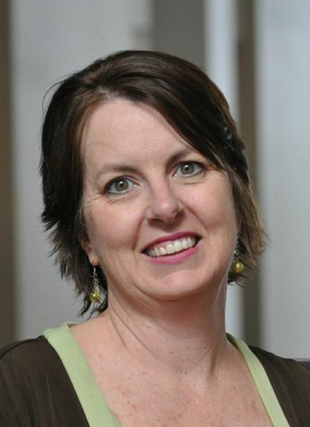  Sonya Milam  Ga. Academy for the Blind | Always room for mere

