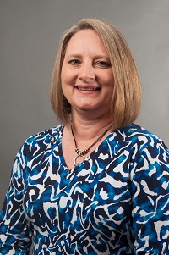  Teresa Bruce  Franklin  Region Rep | 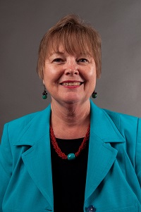  Marsha Sahlman  Hart Region Rep assistant, | 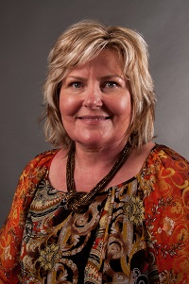  Mellie Caudell  Banks | 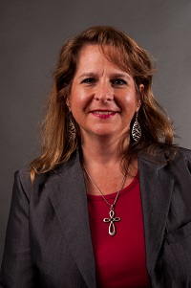  Cyndi White  Barrow  LC past chair | 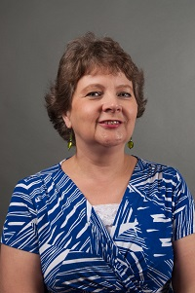  Jerolee Oschack  Clarke | 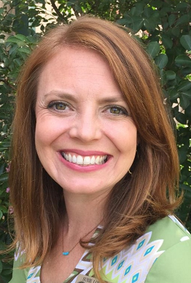  Susie Lovekamp  Columbia | Open  Elbert | 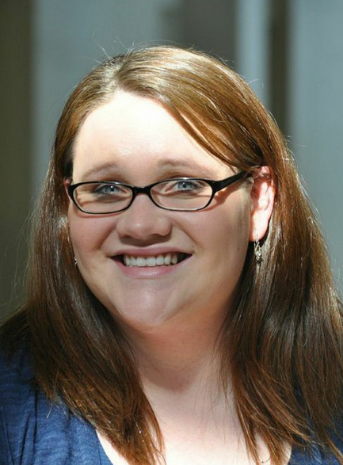  Misty Wise  Habersham
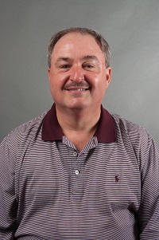  Scott Crain  Hall  LC past chair | 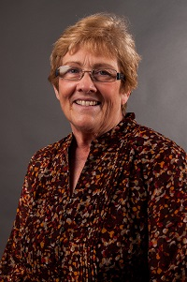  Barbara Bosanko  Lumpkin | 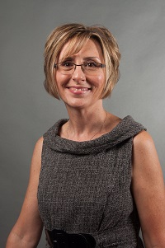  Pamela Walley  Madison  LC past chair | 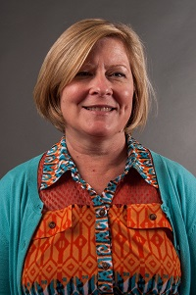  Amy McCollum  Oconee  LC chair elect | 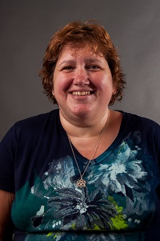  Jodie Zeuke  Oglethorpe | Sharon Lawson  Rabun | 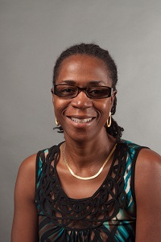  Cassandra Stone  Richmond | Open  Richmond
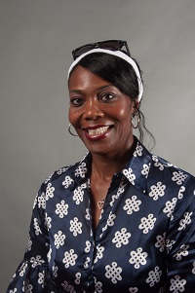  Annetta Mayfield  Stephens | 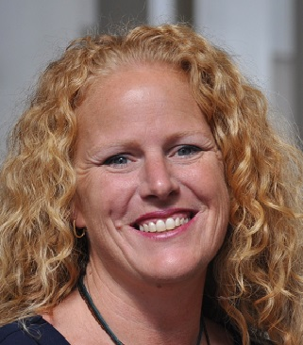  Becky Tracy  Union | 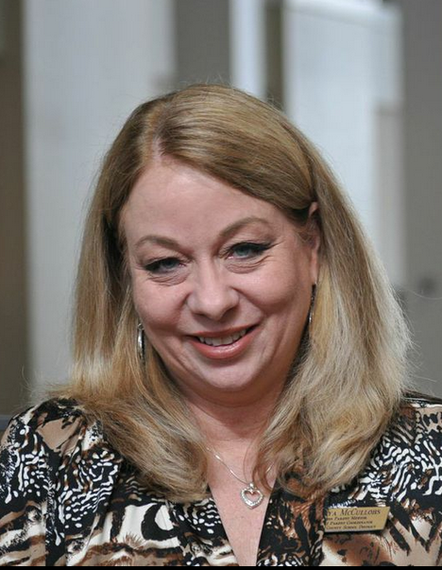  Tonya McCullohs  Walton | 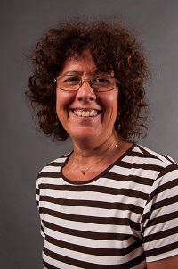  Jane Grillo  White | 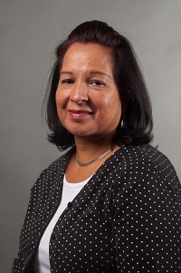  Maritza Rivera  Gainesville City | Always room for more | Always room for more | Always room for mere

