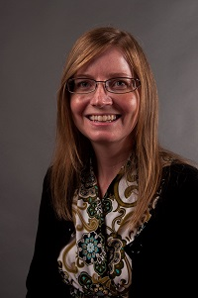  Renee Davis  Douglas  Region Rep | 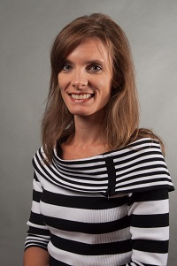  Kim Chester  Bartow | Robin Smith  Catoosa | Jenn Williams  Coweta | 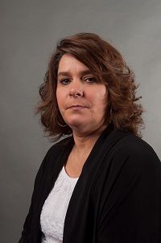Cynthia Daniels  Dade | Together We Can | 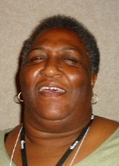  Jean Moorehead  Gordon | 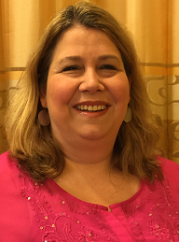  Angela West  Haralson
Together We Can | 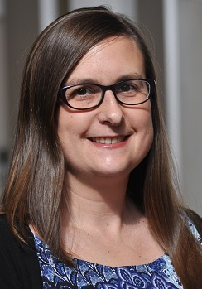  Jena Dennis  Paulding | Tracy Reynolds  Polk | 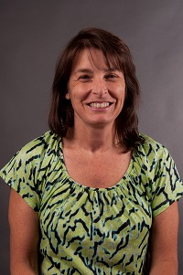  Jodie Mazzolini  Troup | 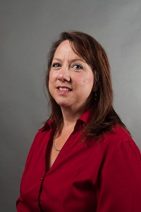  Michal Jones  Walker | 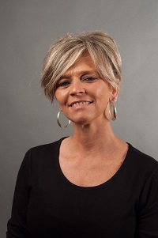  Erin Arledge  Whitfield | Always Room for More | 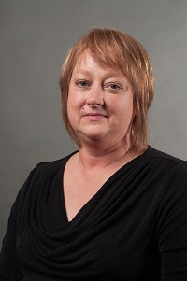  Linda Young  Trion City
Always room for more | Always room for more | Always room for more e | Always room for more | Always room for more | Always room for more | Always room for more | Always room for mere

