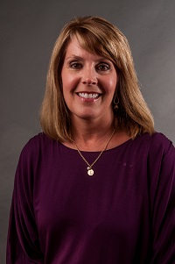  Lori Bonds  Emanuel  Region Rep | 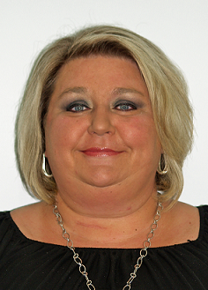  Karen Tharpe  Appling | Open  Brantley | 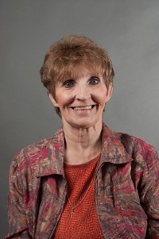  Becky Bryant  Bryan | Open  Bulloch | Jennifer Wright  Candler | 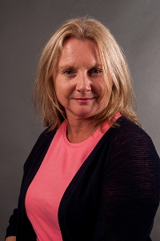  Julie Hardeman  Chatham | Iris Wallace  Chatham
Always room for more | 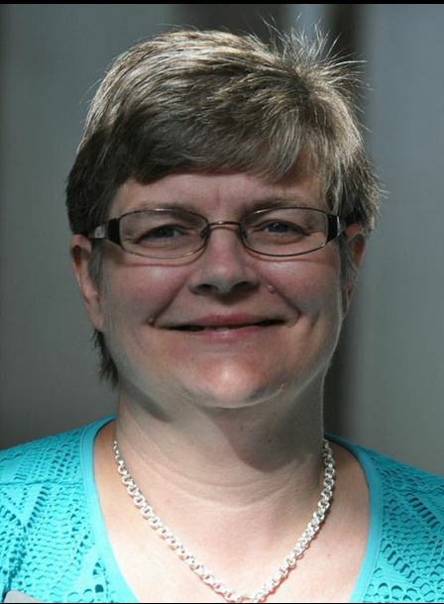  Amy Ambrose  Effingham | 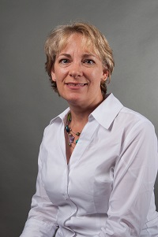  Amanda Locke  Evans | 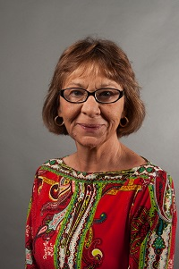  Shirley Moore  Glynn | 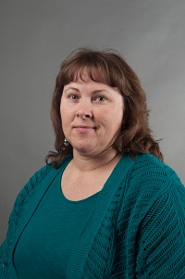  Lisa Vaughn  Liberty | 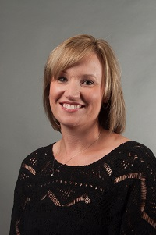  Kristi Murphy  Pierce | 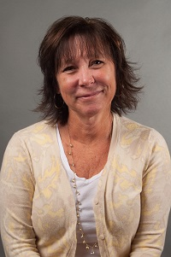  Kim Gibson  Ware | 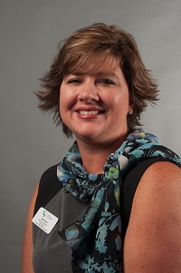  April Lee  Wayne  LC past chair
Always room for more | Always room for more | Always room for more | Always room for more | Always room for more | Always room for more | Always room for more | Always room for mere

