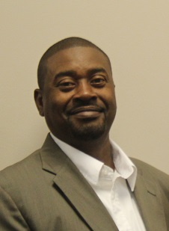  Joseph Randall  Decatur  Region Rep | 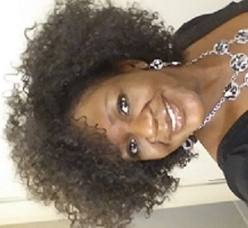  Tracy Barber  Baker  LC past chair | 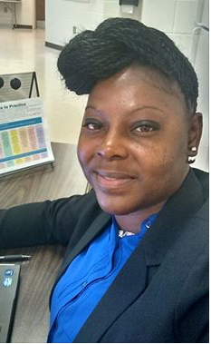  Deanna Williams  Calhoun | Kristi Hodge  Doughtery | 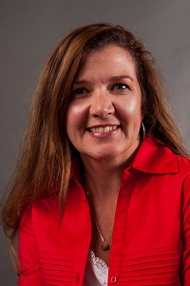  Rebecca Best  Grady | 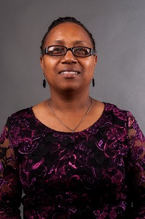  Shanitha Jones  Marion | 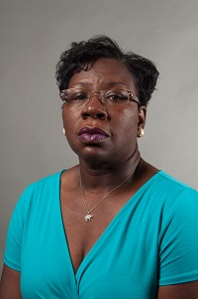  Shirley Daniels  Mitchell | 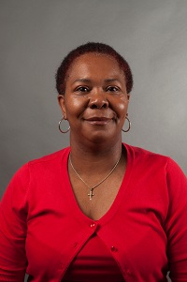  Latonia Mansfield  Terrell
Tiffany Ross  Seminole | A’Kimberly Jones  Stewart | Sharon Reese  Sumter | 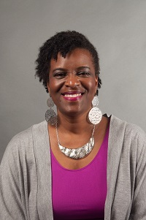  Deborah Bryant  Thomasville City | 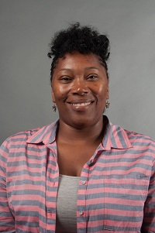  Felisha Draggs  Pelham City | Always room for more | Always room for mere | Always room for more
Always room for more | Always room for more | Always room for more e | Always room for more | Always room for more | Always room for more | Always room for more | Always room for mere
Meeting Dates:

Sept. 2, 2015
Nov. 4, 2015
Jan. 6, 2016
March 2, 2016
May 4, 2016

