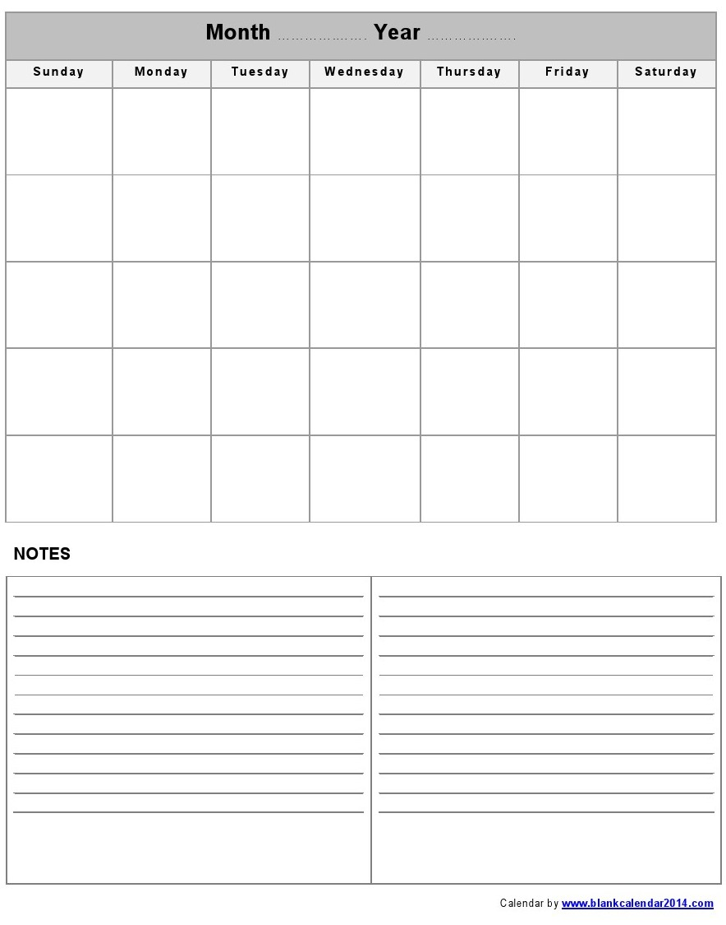

Having ongoing conversations with your child and his/her teacher is important for your child’s success in school. Each week talk to your child about school; ask about their weaknesses and what accommodations are making a difference. Use this calendar to mark when you have conversations, make notes of what is shared, and use the conversation starters if needed. Getting in the habit of these conversations **once a week** is a great proactive practice.

**At-Home Conversation Starters About Accommodations:**

1. "Let's look at your IEP and see if you have any accommodations."
2. "Did you realize you had these?"
3. "Do you use ______in ______class?"
4. "Have you spoken to your teacher about these?"
5. "Do you feel like these help you?"
6. "How does using _________make you feel in class? More independent?"
7. "Do you use these every day?"
8. "Do you talk to your teacher when something is not working?"
9. "Do you know who your case manager is? He/she can teach you how to talk to your teacher if you have a problem."

**Notes: (from conversation with child or contacts with teacher)**

____________________________________________________________________________________________________________________________________________________________________________________________________________________________________________________________________________________________________________________________________________________________________________________________________________________________________________________________________________________________________________________________________