Rookie Training Content for Learning Module

Module 1 – New Mentors

So, you got the job as parent mentor. Congratulations! You have just entered into a partnership where you will be able to take the knowledge and advocacy that you have needed for your own child (or children) and use those tools to help other families and school system staff as well. You might feel rarin’ to go, but, you are not really sure about what you are supposed to do in this new role. That is why we have developed this learning module for first year (or rookie) mentors.

What you will learn:
Mission and Vision of the Georgia Parent Mentor Partnership (GaPMP)
History of the GaPMP
GaPMP Leadership and Community
Taking on Your New Role
Reporting and Responsibilities

Section 1
Mission and Vision of the Georgia Parent Mentor Partnership (GaPMP)
- Mission Statement: Build effective family, school and community partnerships which lead to greater student achievement for all students at risk particularly those with disabilities.

- Vision Statement: Parent mentors and special education administrators will lead the way in Georgia to bridge the gap between home, school and community partnerships.

Section 2
History of the GaPMP

The Partnership, started in late 2001 by Phil Pickens, Special Education Director, Georgia Department of Education, (GaDOE), with Family Engagement Specialist Patti Solomon and a small group of parents and administrators, now boasts more than 100 parent mentors helping families raising children with learning, behavioral and/or physical challenges. Parent Mentors have charted more than one million contacts.

The GaPMP is supported by the Division for Special Education Services and Supports (DSESS). The parent leaders, moms and dads of children with disabilities, are hired by local school districts, state schools and the Department of Juvenile Justice to work with families, school teams, teachers, and the community.
The goal is to build a bridge of communication between home and school that leads to more successful outcomes for students. Parent Mentors partner with families to increase their engagement in education, address individual concerns and also to support initiatives designed to improve all children’s achievement levels.
Parent Mentor work is locally driven, designed to meet the needs of its unique area.
The DSESS hosts an annual Kickoff Conference (usually in September) and regional meetings four times a year in additional to various trainings via webinar and online tools throughout the school year.

Section 3
GaPMP Leadership and Community

There are several people in the Georgia Department of Education’s Division for Special Education Services and Supports who help run the GaPMP.
The first person to know is a former Gwinnet County Parent Mentor who now runs the partnership:
Anne Ladd, Family Engagement Specialist Office
404-657-7328
aladd@doe.k12.ga.us

Some other people from the GaDOE you may want to take note of:
- Richard Woods
- State Superintendent of Schools
- Debbie Gay
- Director, Division for Special Education Services and Supports
- Lynn Holland
- Program Manager

The overriding philosophy of the GaPMP is to include its parent mentor members in the shared leadership of the partnership. This is accomplished through participation in a variety of ways including the Leadership Council and committees.

The Leadership Council membership is made up of seasoned mentors who understand the mission and vision of the GaPMP and wish to help strengthen and improve this initiative.

Leadership Council
- • Chairperson – Amy McCollum, Oconee
- • Chairperson Elect – April Wooten, Jones
- • Vice Chairperson – Edith Abakare, Atlanta Public Schools
- • Recorder – Diane Johnson, Newton
- • Immediate Past Chair- Allison Stevenson, Fayette

- Region Representatives
- • Northeast –Jodie Zeuke, Oglethorpe
- • Northwest - Rene Davis, Douglas
- • Metro – Ashley Gellis, Marietta City
- • Middle –Kathy Simmons, Dodge
- • Southeast - Lori Bonds, Emmanuel
- Southwest - Shanitha Jones, Marion
- Committee Chairs
- Special Projects Kim Chester, Bartow
- Education Patti Grayson, Fulton
- JoEllen Hancock, Cherokee
- Phil Pickens Leadership Award Cyndi White, Barrow
- Sunshine Fund JoEllen Hancock, Cherokee

- Advisors - These are special education directors or administrators
- Ann Cross, Gordon
- Charity Roberts, Coastal GLRS
- Loranda Holmes, Marion

The GaPMP has a website www.parentmentors.org offers general information about parent mentor programs and other useful topics.
Send a professional photo and contact information to jane.grillo@white.k12.ga.us to be added the Find A Mentor pages. This is important! Your Find A Mentor page is like your business card on the GaPMP website.
You will also want to refer to the Learning Curve, the password protected section of the website, which offers mentors access to the forms, documents and other resources you will need to complete annual reporting requirements and, also find shared materials you can use for your work. To access the Learning Curve: click on the tab and then type user name: partnership and password mentor.
Parent Mentors can also connect via a listserve. Contact aladd@doe.k12.ga.us and ask that you be added to parentmentors_georgia@yahoogroups.com.
The GaPMP consists of six regions served by a regional representative who will help mentors with mandatory accountability reporting and quarterly contacts
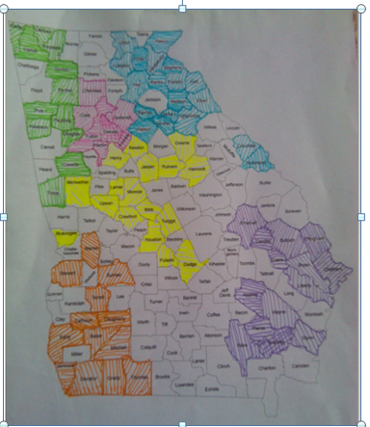
Remember, you can find other mentors by simply going to the Find a Mentor pages on the website and typing the county in the search tab. That will connect you to the mentor’s page if there is one.

Collaboration outside the GaPMP
- Babies Can’t Wait – Skilled Credentialed Early Interventionists
- Bright from the Start: Georgia Department of Early Care and Learning
- Center for Leadership in Disabilities at Georgia State University
- Georgia Council on Developmental Disabilities
- Georgia Department of Behavioral Health and Developmental Disabilities
- Georgia Department of Education, Division for Special Education Supports and Services; Parent Mentor Partnership
- Georgia Family Connection Partnership
- Institute on Human Development and Disability at the University of Georgia
- Parent to Parent of GA – Georgia’s Parent Training Information Center (PTI)

And others such as:
Title I
After School programs
Ga. Vocational Rehabilitation
Local Support groups or Navigator teams
School Social Workers
Local Respite/ Disability services agencies
Churches (especially if they have a Sunday School class for members with special needs)
Special Olympics

Section 4
Taking on Your New Role
As an involved parent, you may know lots of people in your school district. But, as a parent mentor, you will be wearing a new hat and you will need to spend this year getting to know people, learning about what your school district is like from the inside (as a part of school district staff) and, helping staff and leaders in your school district learn about what parent mentors do.
One of the most important things you can do is make sure you spend some time early on with your director. Develop a working relationship (as time and scheduling allows) with your director.
(Elevator speech form)
Send all your contact information (name, title, email address, mailing address, office phone number) to us by filling out the Rookie Contact Form. The form is located in the password protected site for mentor access called the Learning Curve. Go to parentmentors.org and click on the Learning Curve tab. User is partnership, password is mentor. Click on the Rookie Resources tab and scroll down to download the Rookie Contact Form then email it to info@parentmentors.org . This will provide us with information to post on your Find A Mentor page on the parentmentors.org website and on the GaPMP Listserve.

Locate office space, set up the office, telephone, computer, email etc. Facilities vary widely based on factors such as the district size, tax base, location, demographics, etc. It is generally expected that there will be office space in the district for the Parent Mentor; it is helpful if it is near other staff who may be working with families. It is best if parents can call a private voicemail message box so parents may call you directly.

Read the school district’s Policies & Procedures Manual. Discuss the local district’s policies and procedures for: attendance, work hours, personnel actions, phone and email use, dress codes, internet use, travel approval, reporting suspected child abuse, and expense reporting. Some of it may apply only to full time employees, but the information will still be useful. You now represent your school district and professional conduct is expected.

Discuss professional protocols with your Special Education Director. For example, how are media contacts to be managed, who needs to approve letters, brochures, or other materials before they are distributed, who approves travel requests, how is time documented, the dress code, managing schedule changes, reporting deadlines, travel and expense reports, call-in procedures etc.

Parent Mentors and their directors are responsible for attending the annual Kickoff Conference (usually held in September) and four regional meetings each year. You are required to complete several documents: Quarterly Contact Reports, Pre and Post Surveys, Quarterly Reports and End of Year Surveys. *Learn about these in more detail by completing the Reporting and Responsibilities module.

Here are some other helpful hints:
Find your own “mentor” within your department, someone who can introduce you to key people in the district. If possible, work with the director and this local mentor to make a plan for introductions.

Focus on building the important relationships and partnerships, beginning with everyone in your department and moving out into the schools, the district, and the community.

Confidentiality safeguards are important to remember. As an employee, you may not talk about any students with disabilities with anyone unless that person also works with that student. This includes others within the school district, family or friends. It’s easy to get excited about your work and accidently share confidential information. Be careful!!

Boundary setting is critical. As a professional and a school district employee, you must also stay within the boundaries of your job. You can give advice and suggestions as a parent to other parents, but you are not a counselor, teacher, lawyer, or psychologist. You have an important role as a parent who mentors other parents, but it is important to honor the boundaries and not stray into another’s role.

Reporting possible or suspected child abuse: Find out what your school district’s procedures are for reporting suspected child abuse. By state law you are a mandated reporter: http://oca.georgia.gov/mandated-reporter

Respect co-workers by ensuring that you:
Are prepared for meetings with talking points and questions
Arrive on time for meetings and be sure your meetings begin and end on time
Wear district name tag/carry business cards with you
Dress appropriately
Communicate in an open and responsive manner
Respect different perspectives and learn from them
Honor each other’s expertise and experience
Safeguard confidentiality
Maintain accountability at the local and state level

If you are the first parent mentor to serve in your school district, you will need to help people understand your role.
12 Ways to Introduce Yourself (refer to the Rookie Training Guide)

- Introductions at Central Office Staff meetings and Coordinator, Lead Teacher meetings.
- Find opportunities to tell your individual story to central office staff so colleagues can understand the challenges a parent faces and feels raising a child with a disability.
- Your local special education director can send a letter of introduction to school administrators, counselors, teachers, therapists, psychologists, school district partners, etc., describing your role and providing your contact information.
- Create or customize an existing Parent Mentor Brochure with your information. With your Director’s approval, get a sufficient quantity printed for distribution. (Check the Parent Mentor “Learning Curve” online for samples of existing introductory brochures).
- Meet with principals, counselors, and social workers in each school. Plan visits based on your district’s goals and priorities.
- Attend family and community meetings and listen. Make sure you introduce yourself at the meetings.
- Meet with individual school PTA/PTOs. Determine if ALL parents are being included and how you can help. Contact the partners on your community map. Call the GAP2P representative for your area and introduce yourself.
- Build relationships and partnerships with leaders to work towards including ALL parents in their activities – especially Title I and English Language Learners programs.
- Provide information about the Parent Mentor program to local newspapers, with prior approval from your Director and district Media Coordinator/Public Relations Director. Learn the approval protocol for any flyer, news item etc. and never distribute any information without first obtaining approval according to the local policy. Also find out what to do if a member of the media contacts you directly. Often you will need to refer the call to the Media Coordinator/Public Relations Director before responding to any requests for information or interviews.
- PTA/PTO newsletters, again with prior approval as required by your school district.
- Mail an introduction letter to every family with a student who has an IEP and/or send a letter to every teacher. By now you know you need prior approval to send the introductory letter.
- Distribute your contact information to intake staff, social workers, psychologists, counselors and diagnosticians to be given to parents at the time of referral or evaluation.

Some things you are NOT in your role as a parent mentor
A paid advocate
A watchdog
An attorney
A diagnostician or clinical psychologist
A police officer
A DFCS Childrens Services Investigator
A teacher or principal

Module 1 Quiz

- “Build effective family, school and community partnerships which lead to great student achievement for all students particularly those with disabilities.”
The above statement is: an oath taken by every parent mentor
the Georgia Parent Mentor Partnership Mission Statement
state education law

- The GaPMP is supported by the Division for Special Education Services and Supports (DSESS). The parent leaders, moms and dads of children with disabilities, are hired by local school districts,state schools and the Department of Juvenile Justice to work with families, school teams, teachers, and the community.
True False

- The Georgia Parent Mentor Partnership was founded 2001 by Phil Pickens, Special Education Director, Georgia Department of Education, (GaDOE), with Family Engagement Specialist Patti Solomon and a small group of parents and administrators.
True False

- Leadership of the GaPMP is made up of parent mentors and director advisors who have a parent mentor in their district.

True False

- It is not necessary to learn about what your school district’s policies are for submitting and approving brochures, press releases and all printed materials prior to sending out a brochure, introductory letter or conducting an interview with the local newspaper about your new role as a parent mentor.
True False

- It is important to meet with your school district’s special education director and discuss what your job duties will be and what he/she wants you to work on this year.
True False
- Understanding the importance of confidentiality is vital in your role as a parent mentor.
True False

- To learn more about being an employee of your school district, including: attendance procedures, work hours, phone and email use, travel approval, mandated reporting, and other workplace rules you would consult the:
GaPMP Learning Curve
School Districts Policies and Procedures Manual
Ga DOE website
PTA president
- As a professional and a school district employee, you can give advice and suggestions as a parent to other parents, but you are not a counselor, teacher, lawyer, or psychologist. You have an important role as a parent who mentors other parents, but it is important to honor the boundaries and not stray into another’s role.
True False

- If I wanted to see if there was a parent mentor in the next county over, I could:

Go to the GaPMP website Find A Mentor pages and type the county name in the search bar

Contact the Region Rep and ask them

Go on the listserve and ask

All of the above

Reporting and Responsibilities

One of the requirements of being a parent mentor is reporting on the work you are doing in your district and keeping track of the number of parents (students, staff and community members) you have trained.
In this module you will learn about
Section 1 Reporting - location and types of documents
Section 2 - Quarterly Contact Reports
Section 3 - Big Questions to Ask Before You Begin
Section 4 - Tools You Can Use and Other Helping Hands

Reporting and Responsibilities
All documents for reporting are on the Learning Curve of the Georgia Parent Mentor Partnership website
www.parentmentors.org Click on the Learning Curve tab
user name is partnership
password is mentor
The reporting documents you will need to become familiar with:
Contact Tracking Reporting
Quarterly Reporting
Pre and Post Surveys
End of Year Surveys

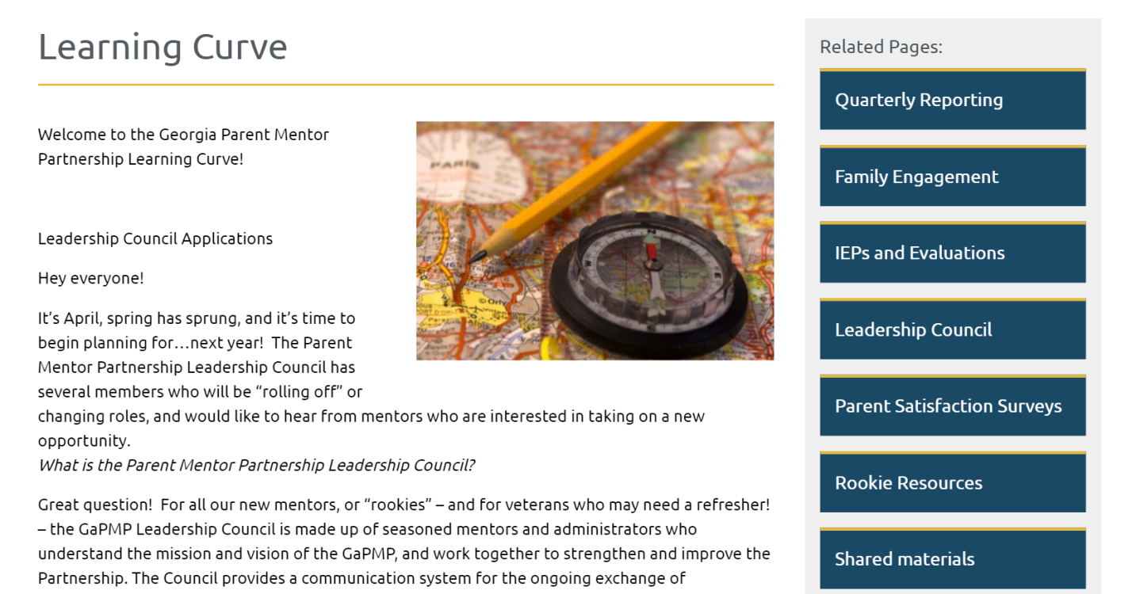

Quarterly Contact Reporting

Four times a year parent mentors report on the kinds of interactions and trainings they have accomplished. There are numerous categories, like did you attend an IEP meeting with a family, or, one on one phone conversations, or hosting a training.

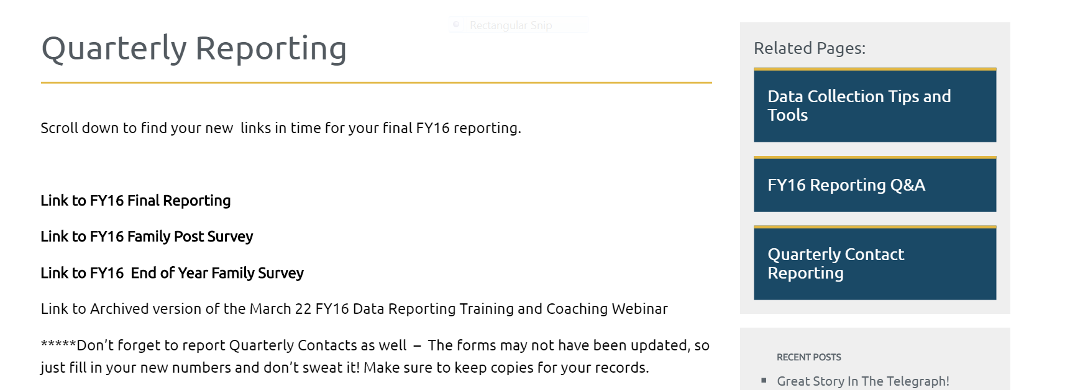

This page offers detailed explanations on how to report contacts and also offers blank pages so you can keep tabs on a paper copy, or scan them in and save them as a google doc to share with your director. You can also print copies of the google doc as you fill it out online. You will discover the process that works best for you.

There are several other reports you will need to complete during the course of the school year.

What does my director want me to work on? This is a very important conversation to have with your director as a new parent mentor.
Some big questions to ask before you begin
Transition?
Pre-K school transition and readiness?
Improving Graduation Rates for Students with Disabilities?
Improving Post Secondary Outcomes for students?
Involving community partners?
Creating opportunities for more authentic engagement?

One place to look is your system’s most recent Parent Satisfaction Survey results and look for the areas where parents reported they were least satisfied.
There is a tab on the Learning Curve which offers information on results. Your director will also have this information:
Your director might talk with you about Statewide Indicators (LINK) and your district’s work on the Student Success Imagine the Possibilities (SSIP) Initiative (LINK)

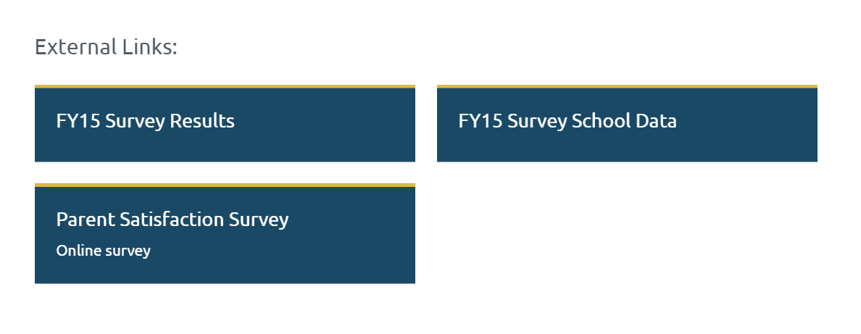
Let’s say you decided to work on Graduation Rates for Students with Disabilities. The next thing you will need to do is determine what you will train parents to do to help improve those numbers.
Why are you going to train parents?
Research on dropout rates shows that parent involvement can impact a student’s decision to stay in school

OK, so how do I decide what to train and how to find out if parents are learning or benefitting from the training.
VITAL BEHAVIORS

V

Vital Behaviors are changes or activities which parents practice on a regular basis. Like, checking to see if their child completed their homework and marking a communication log.
Parent Mentors have three tools at their disposal to help write vital behaviors and find ways to collect the needed data to show that the training you are offering is being put into practice.

Evidence to Practice Guides ---
These are located with the documents on the Quarterly Reporting page of the Learning Curve
There are three: Graduation, Post Secondary and Partnerships Each of these aligns with the bigger category of what your district wants you to work on:
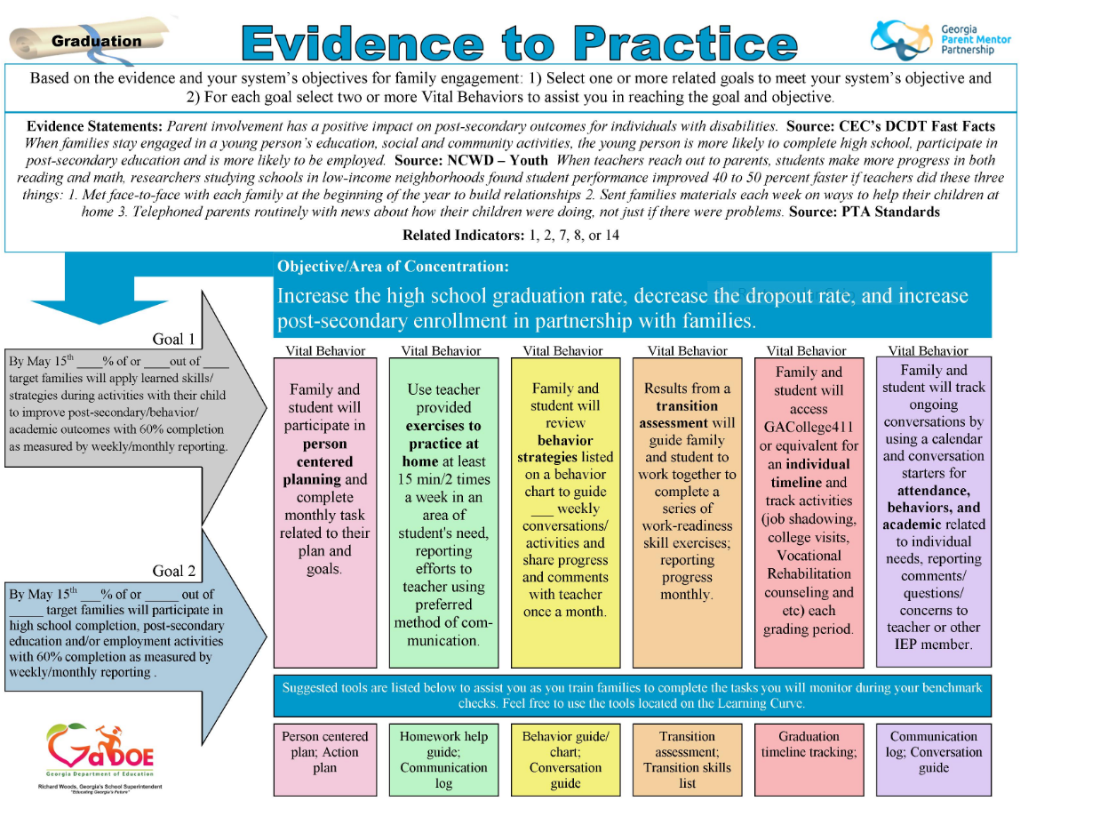
The website also has helpful downloadable webinars and training tools to help you become better acquainted with the Evidence Based research on family engagement, vital behaviors and reporting. We understand that you will need time and assistance to create a program.
WE ARE THERE TO HELP!!!! Region meetings and connecting with your Region Rep are helpful ways to get advice on reporting, vital behaviors AND

Choosing a Target Group

The target group is important because that is how you will be able to compile data on the number of parents who attended trainings and began practicing the vital behaviors you are training on.
Start with a small number of parents - no more than 10.
Once you have chosen them you will start with a pre-survey to see where they are relating to parent satisfaction in the schools:

You can choose to download a paper survey or have your families pull up the survey as a google doc.
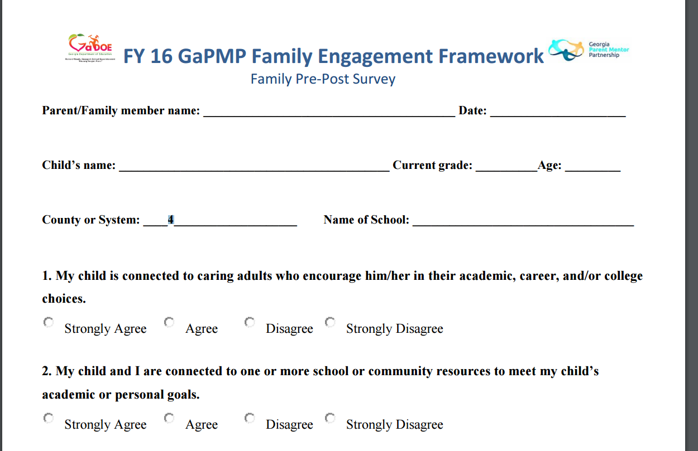

Then you will need to do a post survey at the end of the year asking the same questions AND an end of year survey you will do one time. Again, there is a paper survey which you can download, or you can choose to offer parents the link to a google doc

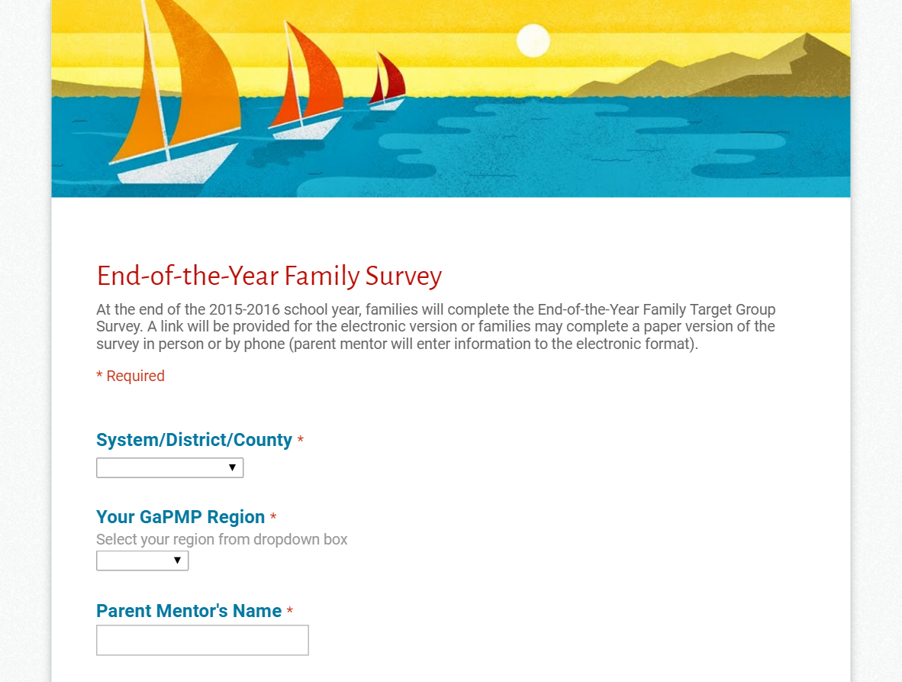

And you will do a quarterly report showing progress on Vital Behaviors
This is a link on the Learning Curve to a google doc as well. These are filled out quarterly on
Oct. 15, Jan. 15, April 15 and May 30 (or your last day for that school year)

