Featured Speakers

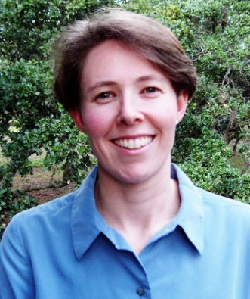
Emily Rubin, MS, CCC-SLP
Healthy Relationships Build Strong Learners
Research in the neuroscience of social emotional development has helped us clarify that a child’s brain development does not lead to stronger social connections and social engagement, it is actually the other way around. All children need frequent and positive social connections and engagements to fuel their brain development and learning. These positive social relationships fuel a child’s interest in the social world, a child’s ability to learn by watching and imitating others, develop language skills to connect and share experiences, and ultimately a child’s higher-level executive functioning. Positive social connections and relationships, in fact, build strong learners at home and at school. Critical priorities can be derived from contemporary neuroscience that guide us as parents and educators when children are beginning to communicate, developing language, and striving to succeed in a range of social situations at the conversational level.
Emily Rubin is the Director of the Educational Outreach Program at the Marcus Autism Center, an academic affiliate with Emory University and an NIH Autism Center of Excellence. She is a speech-language pathologist specializing in autism, Asperger’s Syndrome, and related social learning disabilities. As a former adjunct faculty member and lecturer at Yale University, she has served as a member of their Autism and Developmental Disabilities Clinic. She recently participated as a member of the American Speech-Language-Hearing Association’s Ad Hoc Committee on Autism Spectrum Disorders (ASD), a committee charged with developing guidelines related to the role of speech-language pathologists in the diagnosis, assessment, and treatment of ASD. She is a co-author of SCERTS, a criterion referenced assessment tool and framework for social and emotional development. She lectures internationally and provides consultation to educational programs developing programs for social and emotional learning and engagement in the classroom setting.
Maven Makers
Let’s Make Something Together!
Co-founders of Maven Makers, Ty Donaldson & Tim Cone's collaboration with the local school district's CBVI Program has given SWDs access to green jobs and vocational opportunities by teaching these students how to create beautiful coasters and cheese boards from recycled wood. These hand crafted pieces are now being sold in boutique stores and farmers markets in our community! In addition to learning wood working skills, these students have gained so much more through development of their self-determination skills and self-confidence.

Stephanie M. Hadaway, Ed.S
Falling Up: A New Perspective
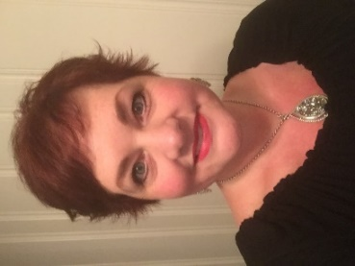
Stephanie M. Hadaway, Ed.S., LPC, is currently the behavior specialist for the Bartow County School System. She has spent over fourteen years providing educational and behavioral support within the public school system. She is a certified teacher who has worked in both elementary and middle schools in the inclusive, resource, and self-contained settings. She coauthored the book, Practitioner’s Guide to Functional Behavioral Assessment: Process, Purpose, Planning, and Prevention. Ms. Hadaway received her Master of Education in Guidance and Counseling from the University of Tennessee at Chattanooga and her Educational Specialist (Ed.S.) in Educational Leadership from Nova Southeastern University. In addition to education, Ms. Hadaway has a rich background in child and adolescent therapy. As a Licensed Professional Counselor (LPC) in Georgia, she has worked with adults, couples, adolescents, and children with a variety of mental health needs. Specifically, Ms. Hadaway has specialized in serving children and adolescents with severe emotional disturbance in both outpatient and day treatment settings. She has facilitated groups, worked with families, and provided individual therapy.

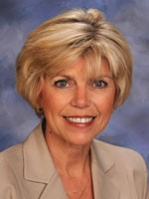
Carol Seay, Ed.D
Using your Parent Satisfaction Data
Carol Seay, Ed.D is the Part B Data Manager at the Georgia Department of Education. She has served as a special education teacher of students with intellectual disabilities, an assistant principal, and a Special Education Supervisor and Director in a large Metro Atlanta District. Prior to joining the Georgia Department of Education, Dr. Seay was the Assistant Superintendent for Special Student Services in her district. Dr. Seay holds a Master’s degree in Special Education and a Specialist and Doctoral degree in Educational Leadership. She resides in Marietta, GA and has 3 children and 4 grandchildren.
Zelphine Smith-Dixon, State
Hang Your Hat on Student Success
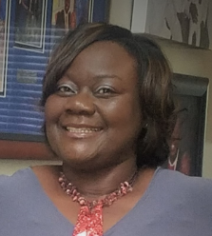
Dr. Zelphine Smith-Dixon is the State Director for the Division for Special Education at the Georgia Department of Education. She has worked diligently to improve outcomes for Georgia’s children. Prior to being an educational leader in Georgia, Dr. Smith-Dixon worked for the South Carolina Department of Education in a leadership capacity supporting low performing schools. During her career, she has been recognized as Tri-County Special Educator of the Year, Vance-Providence Elementary Teacher of the Year, and Orangeburg Consolidated Three Alternate District Teacher of the Year. Zelphine has delivered numerous keynotes, motivational speeches, and national presentations.
Dr. Smith-Dixon is committed to changing the landscape for Georgia’s Student Success.

