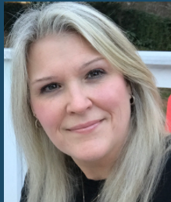  Ashley Gellis  Marietta City  Region Rep  LC Vice Chair Elect | 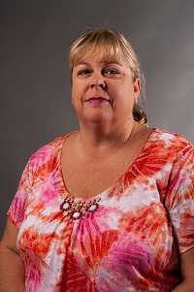  Sharon Jones  Cherokee | JoEllen Hancock  Cherokee  LC Sunshine Fund | Together  We  Can | 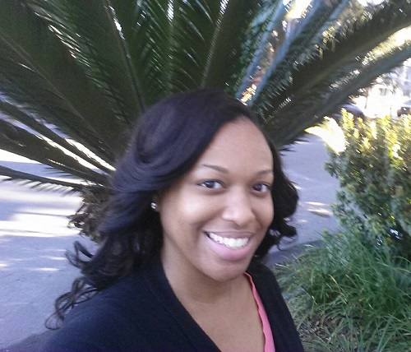 Ashley Wallace  Clayton | 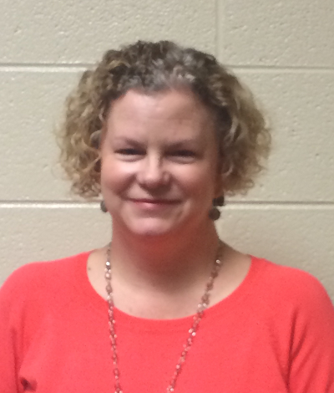 Stacy Greene Cobb | Antoinette  Nichols  Cobb | 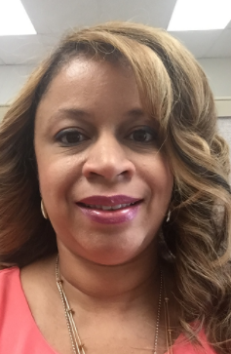  Demetra Williams  DeKalb
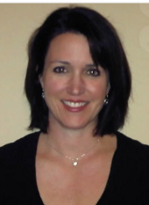  Alexandra Wright  DeKalb | Renee Davis  Douglas | 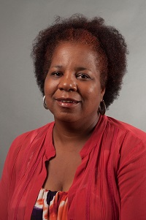  Sabrinia Gresham  Fulton | Open  Fulton | 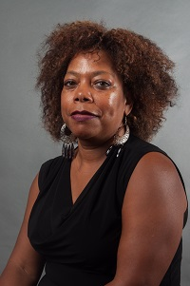  Jackie McNair  Gwinnett | 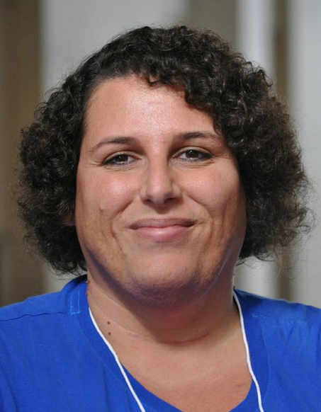  Dawn Albanese  Gwinnett | 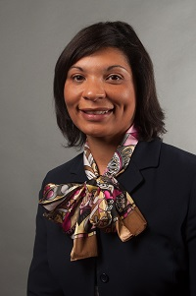  Vernita Harris  Muscogee | 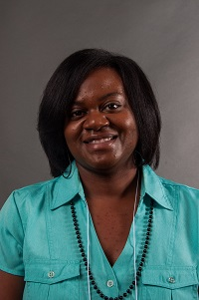  Lakisha Smith  Muscogee
Sirena Graves  Rockdale | 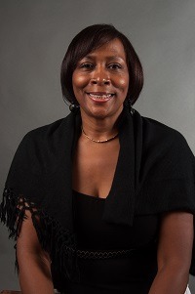  Edith Abakare  Atlanta City  LC Council Chair | Open  Atlanta City | 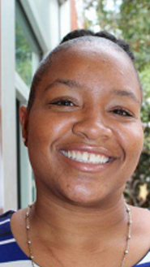  Cheryl Grant  Decatur City | 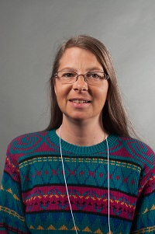  Jennifer Anderson  Ga Cyber  Academy | 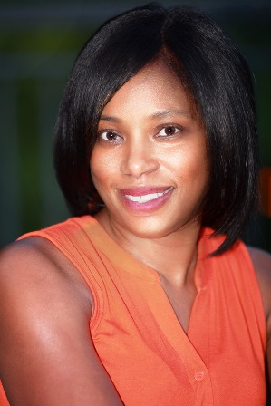  Doricia Thompson  DJJ | Always room for mere | Always room for mere

