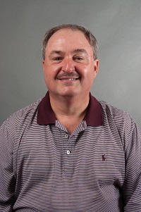  Scott Crain  Hall  LC past chair Region Rep | Open  Barrow | 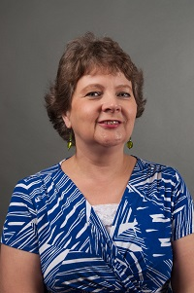  Jerolee Oschack  Clarke | Latoya Roper  Columbia | Open  Jackson | 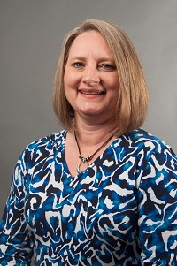  Teresa Bruce  Franklin | 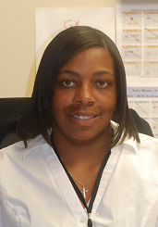  Jacqueline Evans  Greene County | Open  Madison
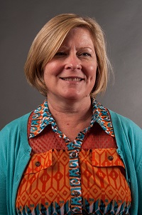  Amy McCollum  Oconee  LC past chair | 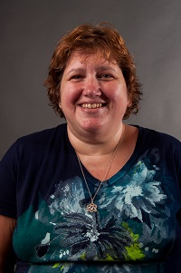  Jodie Zeuke  Oglethorpe | 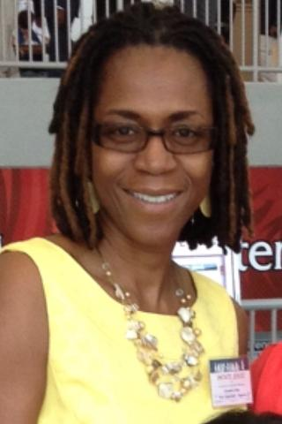  Cassandra Stone  Richmond | Open  Richmond | 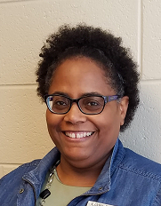  Lori Rose  Stephens | 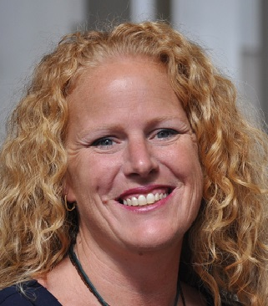  Becky Tracy  Union | 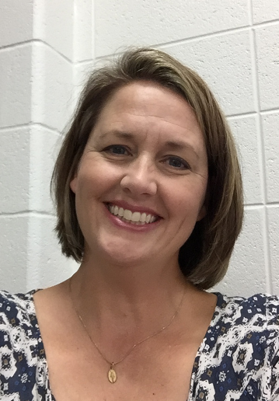  Bonnie Morris  Walton | 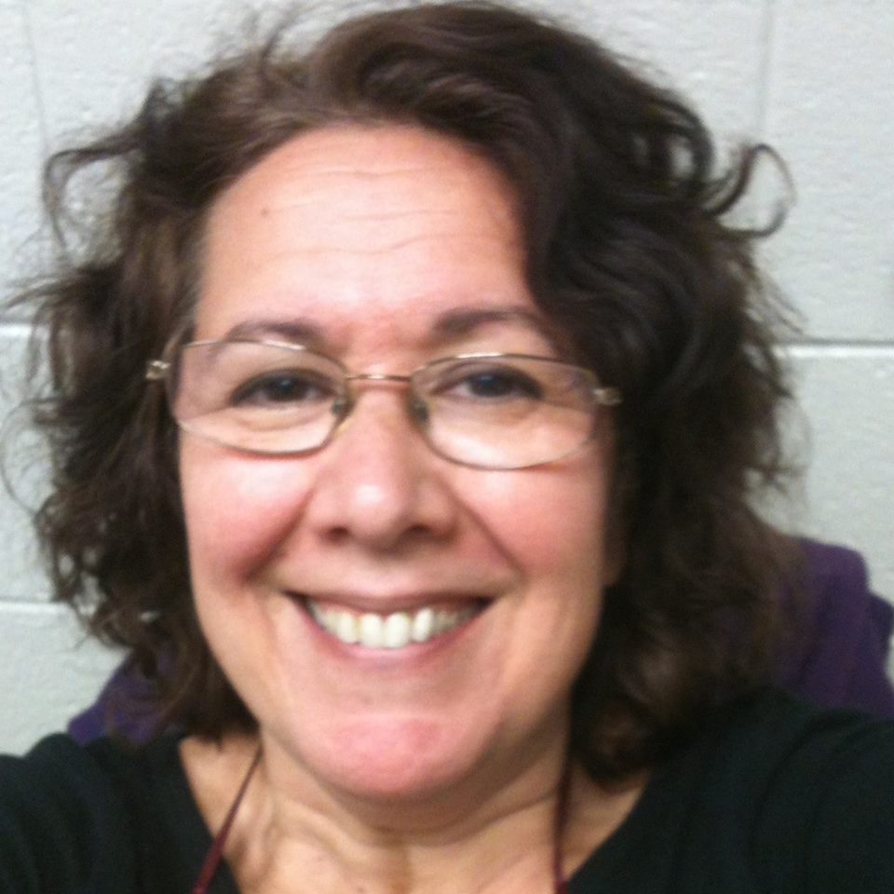  Jane Grillo  White
 |  |  |  |  | Open  Gainesville City | Always room for more | Always room for mere

