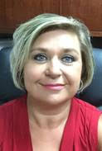  Karen Tharpe  Appling  Region Rep | Open  Brantley | Celena Hughes  Bryan | 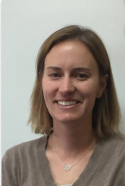  Fay Blythe  Bulloch | Terry Bland  Candler | 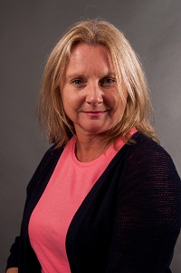  Julie Hardeman  Chatham | Letisha Bready  Chatham | Together  We Can
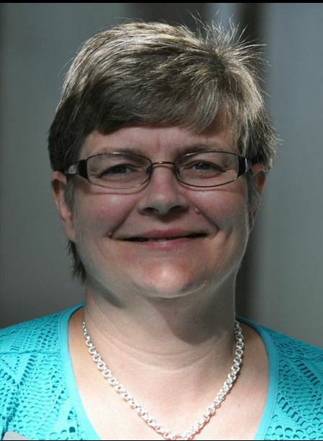  Amy Ambrose  Effingham | 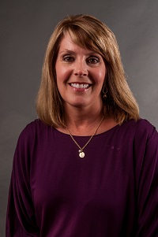  Lori Bonds  Emanuel | 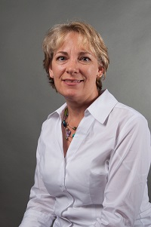  Amanda Locke  Evans | 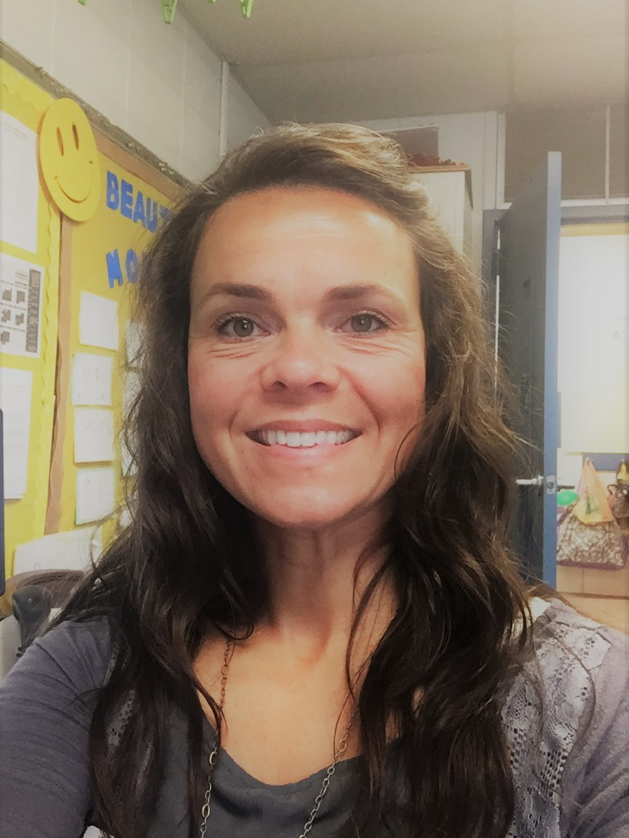  Billie Foulk  Glynn | 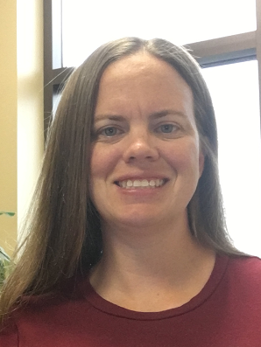  Tomesha Giddings  Liberty | 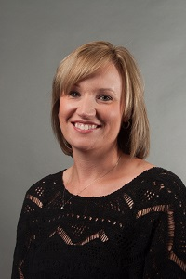  Kristi Murphy  Pierce | 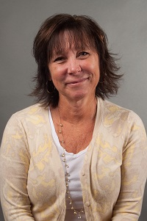  Kim Gibson  Ware | Together  We Can

