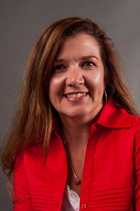  Rebecca Best  Grady  Region Rep | Open  Baker | Open  Calhoun | 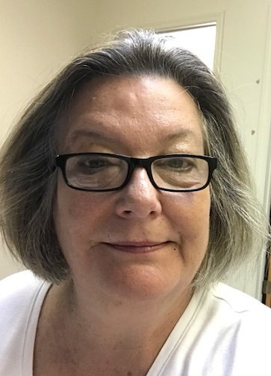  Kit Griffin  Decatur | Kristi Hodge  Dougherty | Shanitha Jones  Marion | 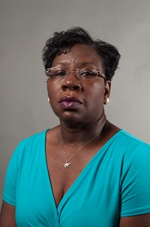  Shirley Daniels  Mitchell | 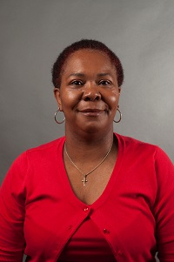  Latonia Mansfield  Terrell
Tiffany Ross  Seminole | Open  Stewart | 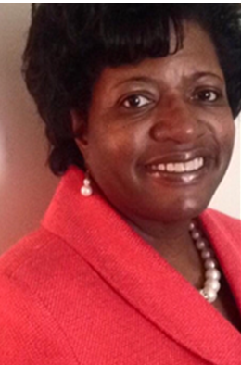  Sharon Reese  Sumter | Bernadette Bennett  Pelham City | 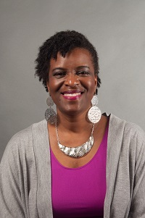  Deborah Bryant  Thomasville City | 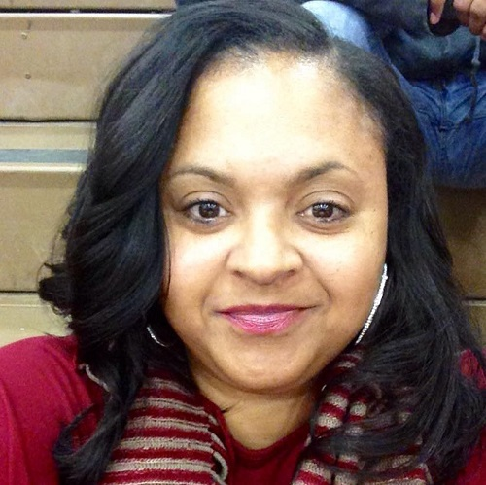  Contina Smith  Valdosta City | Always room for more | Always room for more

