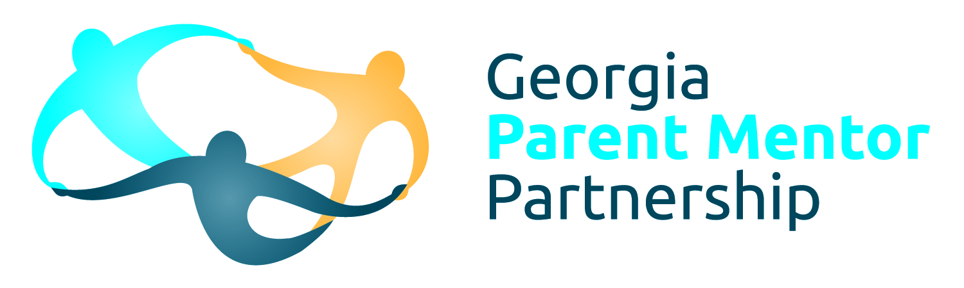
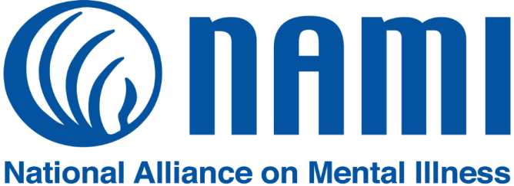

Resource Links
3 LEVELS OF NAMI (The National Alliance on Mental Illness): National, State, Community
- National NAMI: Who We Are
- State NAMI Georgia
- Local NAMI Georgia Affiliates & Support Groups
FAMILY VIEWS
- Mayim Bialik. PSA for NAMI
- Max Silverman (brother)
- Theo Bennett Speech at NAMI National Convention discussing his father's mental health
- Liza Long: A Parent's Perspective on Mental Illness

IN YOUR COUNTY
- Georgia Crisis and Access Line 24/7 Immediate assistance, mobile crisis, home & schools, ask for CIT Trained Officer
- Community Service Boards (CSBs) DBHDD provides behavioral health & DD services in community.
- LIPT (Local Inter-agency Planning Team) Group of stakeholders who meet monthly focusing on at risk youth and children.
- Georgia Family Connection is a great place to network with others serving families and community.
- The Kinship Navigator Program Help for grandparents, relatives, and other caregivers raising a child.
- Finding a Kinship Navigator to help grandparents and other relatives raising a child.
- DFCS find your county office.

SUICIDE RESOURCES
- The Link Counseling Center , 348 Mount Vernon Hwy. NE, Atlanta, GA 30328, focuses on suicide prevention and aftercare of those affected by suicide. Check here for SOS Training.
- ASIST Suicide Prevention Training Two Day Training currently being offered in Chatham County
- QPR Training It is usually offered free by DBHDD, but I couldn't find a current class. The website listed charges $29.95. I tagged GA Tech. They are offering twice a month. I would guess it's free. A QPR overview is included in NAMI Basics, Family-to-Family, Homefront, and other educational classes, but it's not an in-depth training.
- webhealing.com is a website designed to help those dealing with grief and loss.
- Sources of Strength is best practice youth suicide prevention project supported by GA DOE. There are groups in many of our Georgia schools.
- AFSP offers educational training focused on suicide prevention including "safeTALK". Check the page to see what's offered in your area.
- SPAN-GA has purple packets you can order. They create Memory Quilts and offer Camp SOS for children who have lost a family member to suicide.
ADDITIONAL YOUTH SUPPORT/EDUCATION
- Lives in the Balance Dr. Ross Greene fosters collaboration. NAMI Basics & Homefront use Dr. Greene's CPS Method to solve problems.
- Understanding ACEs (Adverse Childhood Experiences)
- TED Talk: Nadine Burke Harris "How Childhood Trauma Affects Health Across a Lifetime"
- Georgia ACEs Connection
- Child Welfare Training Collaborative at GSU will come to your county for free training (Trauma 101, Brain 101, Brain 201)
- Current Calendar for CWTC Sign up for one of these, or get a group in your area to schedule.
- Parent to Parent of Georgia offers free training focusing more on DD.
- Georgia Parent Support Network
- Become a CPS-P (Certified Peer Specialist-Parent). Training is available through DBHDD and is listed on our website.
- Georgia's LIGHT EPT Initative We currently have 6 first episode programs with number 7 in the works funded through DBHDD in our CSB's (Advantage Behavioral Health Athens, Aspire Behavioral Health Albany, McIntosh Trail Community Service Board Griffin, River Edge Behavioral Health Macon, View Point Health Gwinnett, View Point Health DeKalb/Fulton).
- Crisis Text Line One Pager
- NIMH on PANDAS Controversial--some mental health issues may be caused by strep. NIMH gives link to PANDAS Network.
- Georgia Campaign for Adolescent Power and Potential has a list of statewide counseling and mental health services for children and youth.
JUVENILE JUSTICE
- CHINS A Chance to Curtail Delinquency Judge Willie J. Lovett Jr.
- Georgia Dept. of Juvenile Justice serves offenders up to age 21; however, at 17 most juveniles are tried as adults.
- RYDC (Residential Youth Detention Center) short term facilities across the state that serve multiple counties.
- YDC (Youth Development Campus) is a long term facility. There are currently 7 in Georgia.
- Georgia Preparatory Academy Schools within the detention centers.
- Justice Center: National Reentry Resource Center talks about juvenile records. Search the site for other topics of interest including videos and webinars.
- Juvenile Accountability Courts in Georgia: Fulton, DeKalb, Henry, and Chatham are only MH Courts. There are 11 Drug Courts.

SCHOOL INFO
- GNETS (Georgia Network for Educational and Therapeutic Supports) This site has a list of all GNETS, not sure how accurate it is.
- Special Education Rules from GA DOE Website
- Georgia Project AWARE focus on school based mental health.
- Georgia APEX Project has placed therapists in many schools around the state.
- Georgia Student Health Survey Three surveys covering elementary, middle, and high school students.
- Georgia Positive Behavioral Interventions and Supports (PBIS) is being implemented in schools and DJJ.
- IEP Help Page includes webinars about IEP's
- RESA (Regional Educational Service Agency) Each RESA will be facilitating with NAMI GA to schedule Mental Health Awareness Training in schools.
- Georgia Youth Challenge Academy Educational program offered through National Guard for students 16-18 who are having difficulty with traditional high school.
ENDING the SILENCE INFO
- NAMI partners with the 24/7 Crisis Text Line: 741741 . The video with Nancy Lublin explains the system and the importance of the data they collect.
- NAMI created the website ok2talk.org for teens and young adults. The conversations are monitored and removed if inappropriate.
- teenshealth.org focuses on all aspects of health, not just mental health.
- halfofus.com Very good site for college students since most of the story videos are college age.
- thetrevorproject.org helps and supports LGBTQ youth.
- StopBullying.gov Provides information from various government agencies on bullying, risk, prevention and responses.
- jedfoundation.org NAMI often partners with JED. They have a new Mental Health ad campaign called Seize the Awkward to encourage students to start a conversation about mental health with their friends.
- walkinourshoes.org is mentioned in one of the ETS PowerPoints. It's a site that could be used with younger youth.
- Walk in Our Shoes PSA.
ADDICTION ISSUES
- Georgia Council on Substance Abuse offering education, training about substance abuse. They manage a CARES Warm Line.
- National Institute on Drug Abuse
- High School & Youth Trends Even though trends are down, we know students who don't do well in school are at the greatest risk to use.
- Out of Reach Documentary by Dallas GA High School senior about prescription drug abuse in his school (28 minutes).
- SAM Smart Approaches to Marijuana Founded in 2013 by Patrick Kennedy and Kevin Sabet, who worked for Presidents Clinton, GW Bush, & Obama.
RESOURCE GUIDES from NAMI
- Navigating a Mental Health Crisis Resource Guide from NAMI
- Starting the Conversation : College and Your Mental Health
VIDEOS
- Stephen Tonti: ADHD
- Kevin Breel.(depression)
- Joshua Walters (Bipolar)
- Rosie King (autism)
- Liza Koshy on Opening Up about Mental Health
- Samantha Pena (OCD)
- TED Talk: Nadine Burke Harris "How Childhood Trauma Affects Health Across a Lifetime"
- The Kids We Loose, A Documentary Film trailer
HUMAN RIGHTS/LEGAL
- Georgia Advocacy Office is funded by Federal Government.
- Southern Center for Human Rights is supported by private donations.
- Wrightslaw Special Education law does occasional training in Atlanta, but it can be expensive. Information on the website about IEP's. They offer free special ed advocate newsletter.

